# iOS Technologies

App Extensions

App extensions increase the reach of your app, giving users access to focused parts of its functionality while they use other apps. For example, while viewing websites in Safari, people can use your Share extension to post an image or an article to your social website. Or while using Photos, people might use your Photo Editing extension to apply a filter to a photo. (In these scenarios, Safari and Photos are called *host apps* because they give users access to extensions.)

You deliver an app extension inside a fully functional iOS app that you submit to the App Store (an app that contains extensions is called a *containing app*). After enabling the extension in your containing app, people can use it to perform a quick task while they’re using other apps. For example, while reading about a product in an email message, people might use your Action extension to add the product to a shopping list without having to leave Mail.

[Table 17-1](https://developer.apple.com/library/ios/documentation/UserExperience/Conceptual/MobileHIG/AppExtensions.html#//apple_ref/doc/uid/TP40006556-CH67-SW2) lists the types of iOS app extensions you can create.

| App extension type | People use the extension to… |
| --- | --- |
| Today widget | Get a quick update or perform a quick task in the Today view of Notification Center |
| Share | Post to a website or share content with others |
| Action | Manipulate or view content within the context of another app |
| Photo Editing | Edit a photo or video within the Photos app |
| Document Provider | Access and manage a repository of files |
| Custom keyboard | Replace the iOS system keyboard with a custom keyboard |
| **Table 17-1**Types of app extensions | |

The following guidelines apply to app extensions of all types; for guidance that’s specific to a particular type of app extension, see the sections below. (To learn how to develop, debug, and distribute an extension, see [*App Extension Programming Guide*](https://developer.apple.com/library/ios/documentation/General/Conceptual/ExtensibilityPG/index.html#//apple_ref/doc/uid/TP40014214).)

**Enable a single task.** An app extension is not a mini version of your app. Instead, an extension performs a narrowly scoped task in the context of the user’s larger goal. For example, an Action extension might give users a different way to view their current content.

**Keep user interactions limited and streamlined.** The best app extensions let people perform the task in just a few taps so that they can return to their earlier context as soon as possible. For example, a Share extension might let people post an image with a single tap.

**Incorporate the name of your containing app into the name of each extension it provides.**Although multiple extensions in one containing app should each have a unique name, you want to make sure that users understand the relationship between your extensions and your app. People encounter extensions in many different contexts, and they’re unlikely to trust an extension if they don’t recognize it.

**In most cases, use the icon of the containing app.** Displaying a familiar icon is another way an extension can gain users’s trust. Note that in the case of an Action extension, you create a monochromatic version of the containing app’s icon (for details, see [Share and Action Extensions](https://developer.apple.com/library/ios/documentation/UserExperience/Conceptual/MobileHIG/AppExtensions.html#//apple_ref/doc/uid/TP40006556-CH67-SW3)).

IMPORTANT

As with all icons and graphics you design, don’t replicate iOS icons or images and don’t create images of Apple products and designs.

**Avoid displaying a modal view on top of an extension.** Many extensions are displayed within a modal view by default, and it’s best to avoid layering modal views. Although there are cases where users might see an alert on top of an extension, avoid designing an extension workflow that requires a modal view.

Today Widgets

People view Today widgets in the Today area of Notification Center. Because people configure the Today area so that it displays the information they value most, design your widget with the goal of earning a place among the user’s most important items.

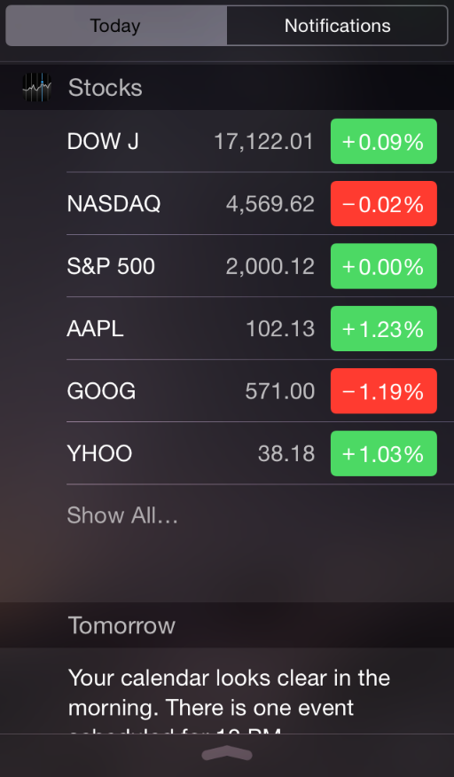

**Design an appearance that looks at home in Notification Center.** When you use the default margins and background appearance provided by Notification Center, your Today widget gives users a consistent experience. For best results, focus on drawing your content and not on drawing backgrounds or other materials. In particular, avoid drawing a solid background.

NOTE

iOS automatically displays your app icon and title above your custom widget content (the icon appears in the leading margin).

**Align content with the widget’s title.** When your widget content aligns with your title, people can easily scan the Today view for the widget they want. Respect the margins in the Today view, and restrain your content to the widget content area shown here.

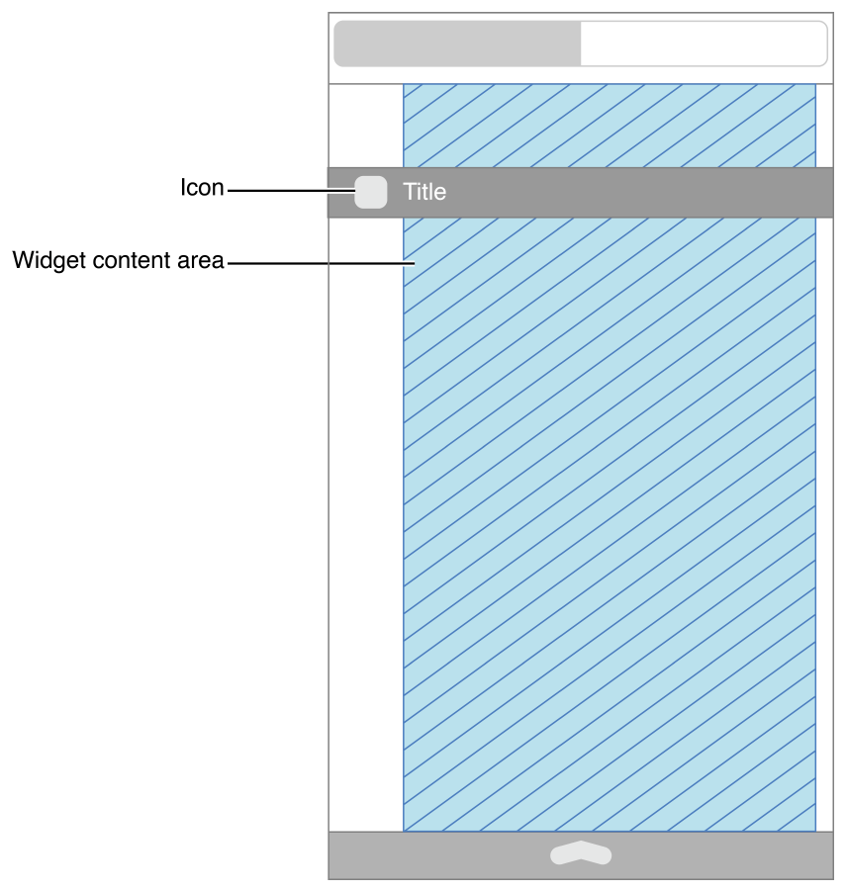

**In general, use the system font in white to display text.** White text looks good on the default Notification Center background. For secondary text, use the system-provided vibrant appearance (to learn more about this appearance, see[notificationCenterVibrancyEffect](https://developer.apple.com/library/ios/documentation/UIKit/Reference/UIVibrancyEffect/index.html#//apple_ref/occ/clm/UIVibrancyEffect/notificationCenterVibrancyEffect)).

**Provide a Notification Center experience.** People visit Notification Center to get brief updates or to perform a very simple task, so it’s best when your Today widget displays the right amount of information and limits interactivity. Specifically:

* Avoid making users scroll or vertically shift the view to see all the information in your Today widget. A widget can expand vertically to show more information, but it’s not a good experience when a widget’s height exceeds the height of Notification Center, because it interferes with scrolling to see other Today widgets.
* Avoid enabling horizontal swiping or dragging, because it interferes with navigation between Notification Center areas.
* As much as possible, let users perform a task or open your app with a single tap (note that the keyboard is not available within a Today widget).
* Optimize performance so that people get useful information immediately. It's a good idea to cache information locally so that you can display recent information while you get updates. People expect to spend very little time in the Today view, and iOS may terminate Today widgets that don’t use memory wisely.

**If appropriate, let people tap your Today widget to open your app.** Because your Today widget provides a narrowly focused experience, it can work well to direct people to your app for more information or functionality. It’s not a good idea to provide an “Open App” button, so one solution is to make your entire Today widget tappable. Or you might let users tap an appropriate UI object within the widget so that it opens your app to a view that’s focused on that object. For example, the Calendar widget shows today’s events; if users want to get more information about an event, they can tap the event in the widget to view it in the Calendar app.

NOTE

Giving users a way to open your app from your Today widget can work well, but it’s essential that you continue to provide useful, timely information in the widget. Avoid creating a Today widget whose only function is to launch your app.

Share and Action Extensions

People access Share and Action extensions by tapping the Action button in an app. In the activity view controller displayed by the Action button, Action extensions are listed in the bottom row and Share extensions are listed above them. People can use the More buttons to manage the Share and Action extensions that are displayed in the activity view controller shown here.

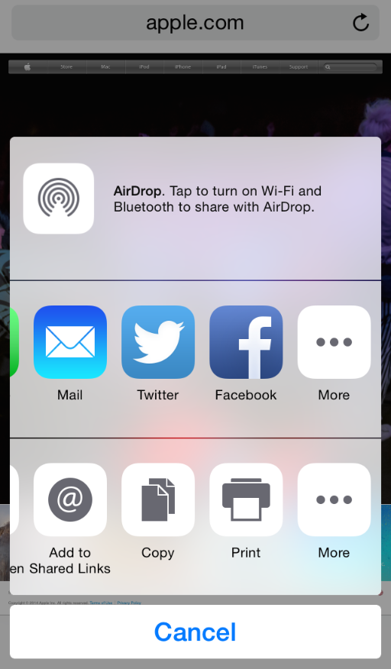

A Share or Action extension typically takes as input the content in the user’s current context. While reading an article in Safari, for example, a user might tap the Action button and use a Share extension to post the article to a sharing website or use an Action extension to view a translation of the article.

NOTE

In the activity view controller, iOS lists only the Action extensions that support the current content type. For example, when the user’s current content is a video, iOS doesn’t list Action extensions that support only text.

**As much as possible, use the system-provided UI in a Share extension.** The system-provided compose view controller gives users a consistent experience and automatically supports common tasks, such as previewing and validating standard items, synchronizing content and view animation, and configuring a post. To learn more about using the system-provided compose view controller, see [Share](https://developer.apple.com/library/ios/documentation/General/Conceptual/ExtensibilityPG/ShareSheet.html#//apple_ref/doc/uid/TP40014214-CH12) in [*App Extension Programming Guide*](https://developer.apple.com/library/ios/documentation/General/Conceptual/ExtensibilityPG/index.html#//apple_ref/doc/uid/TP40014214).

**Consider displaying the progress of a lengthy upload in a Share extension’s containing app.** People expect to return to their previous context immediately after tapping an extension’s Post or Share button, even when the shared content is large. You need to make progress updates available, but people don’t want to get a notification every time an upload completes, and there’s no way to programmatically relaunch an extension. In this scenario, it can work well to display the progress of the upload in the containing app, which can handle the task in the background and send a notification if there’s a problem.

**Use a monochromatic version of the app icon for an Action extension.** (In contrast, a Share extension uses its containing app’s full-color app icon.) To create an icon for an Action extension, you might start by creating a stencil version of your app icon. If necessary, simplify the design by focusing on the elements that make your icon unique.

If you provide multiple Action extensions in your containing app, it can work well to create a family of icons for them. Be sure to make every icon in the family look related to the containing app’s icon.

Photo Editing Extensions

People can use Photo Editing extensions while they view photos or videos in the Photos app. Typically, a Photo Editing extension helps a user apply a filter or make some other edit to a photo or video. After the user confirms the change, the edited content is available in Photos.

Photos provides a modal view that displays the custom UI of your Photo Editing extension. Photos can also display a confirmation view when the user chooses Cancel after applying edits to a photo or video (you’re responsible for enabling this behavior in code).

**Avoid using a navigation bar in your Photo Editing extension.** As you can see here, the modal view that encloses your extension’s view already includes a navigation bar; adding another navigation bar would take space away from your UI and be confusing to users. (By default, Photos displays your view at full-screen height, so your content will appear underneath the built-in navigation bar.)

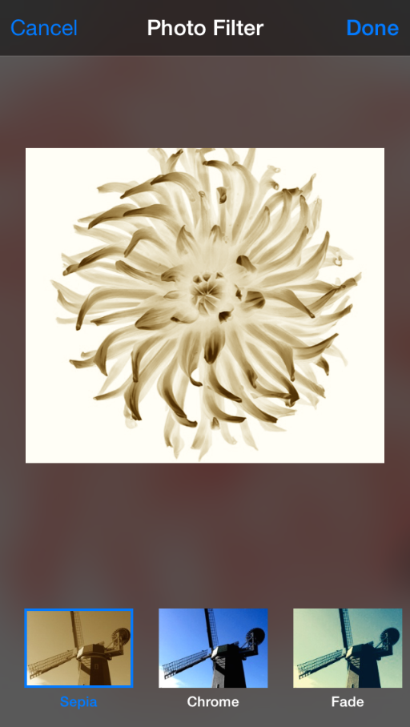

**If appropriate, let users preview their edits.** As much as possible, you want to let users see the results of their work before they close your extension and return to Photos.

Document Provider Extensions

A Document Provider extension helps people access the documents that your app manages from a wide range of other apps. In a host app, a document picker view controller displays the UI that your extension provides (to learn more about the document picker view controller, see[*UIDocumentPickerViewController Class Reference*](https://developer.apple.com/library/ios/documentation/UIKit/Reference/UIDocumentPickerViewController_Class/index.html#//apple_ref/doc/uid/TP40014342)).

NOTE

A Document Provider extension can consist of two separate parts: a Document Picker View Controller extension and a File Provider extension. The Document Picker View Controller extension contains your custom UI; the File Provider extension implements access to files. For simplicity, this section uses the term*Document Provider extension* to refer to the UI and experience provided by the Document Picker View Controller part of the extension.

**Avoid using a navigation bar in your Document Provider extension.** iOS displays your extension’s custom UI within the navigation bar–based interface of the document picker view controller. Displaying a second navigation bar below the built-in bar is confusing to users and takes space away from your content. (By default, the document picker view controller displays your view at full-screen height, so your content appears underneath the built-in navigation bar.)

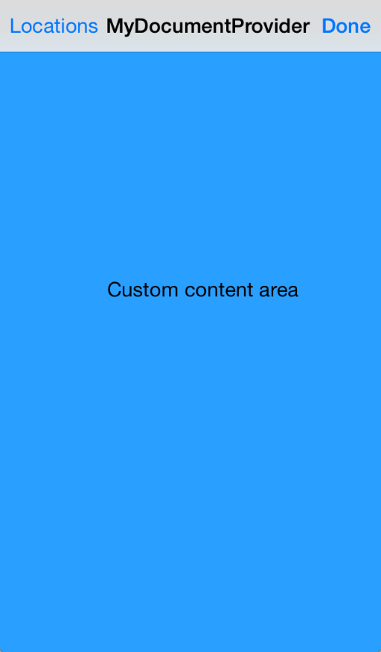

Custom Keyboards

People use a keyboard extension to replace the iOS keyboard with a custom keyboard throughout the system. After enabling a keyboard extension, people get the custom keyboard when they enter any text entry area except for secure text entry areas (such as a password field) and phone pad areas (such as a phone number field in Contacts).

**Provide an obvious way for users to switch to the next keyboard.** People are very familiar with the iOS globe key, and they expect a similar experience in your keyboard.

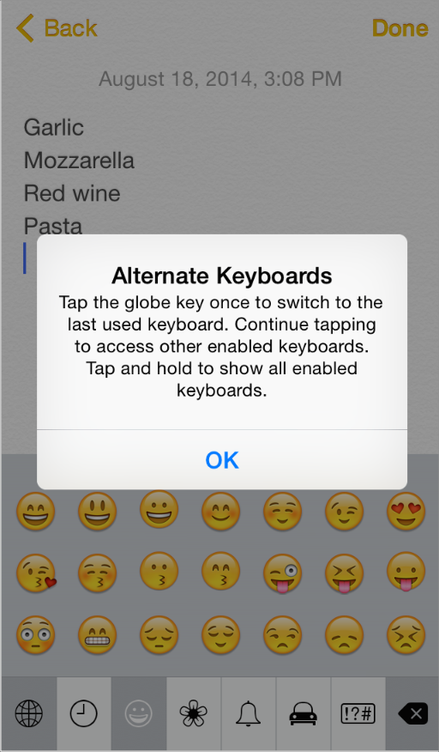

Notifications

Notifications give people information and functionality that’s important right now. People can get notifications in various contexts, such as on the lock screen, while they’re using apps, and when they visit Notification Center.

Notification Center has two views: Today and Notifications.

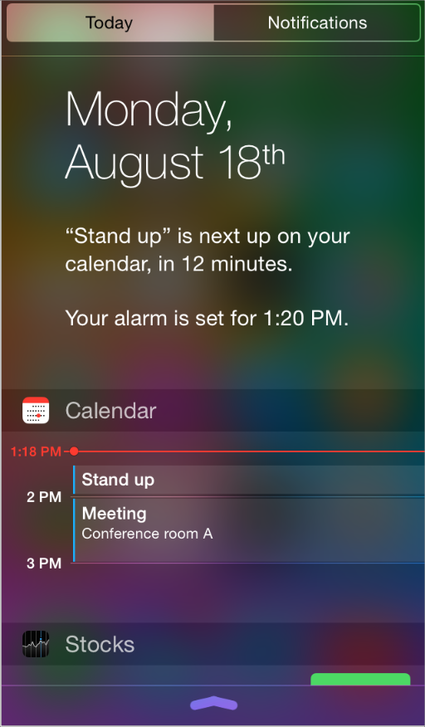

The Today view displays an editable list of widgets. A Today widget is an app extension that displays a small amount of timely, high-value information or functionality that’s provided by an app the user cares about. For example, the Calendar widget displays only today’s events. Tapping an event in the Calendar widget opens that event in the Calendar app, where users can edit the event and manage other events. To learn more about designing a Today widget, see [Today Widgets](https://developer.apple.com/library/ios/documentation/UserExperience/Conceptual/MobileHIG/AppExtensions.html#//apple_ref/doc/uid/TP40006556-CH67-SW4).

The Notifications view displays recent notification items from apps that users are interested in. Users can visit an app’s area in Settings to specify whether they want notifications from the app to appear in Notification Center.

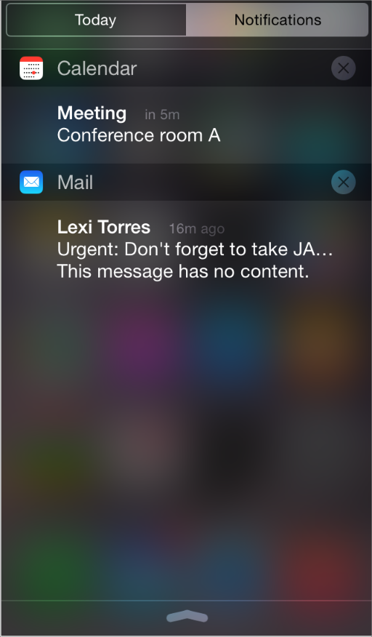

iOS apps can use notifications to let people know when interesting things happen, such as:

* A message has arrived
* An event is about to occur
* New data is available for download
* The status of something has changed

In iOS 8 and later, apps can define actions that users can take within a notification. For example, a notification from a to-do app might let users mark an item as done without having to open the app.

iOS defines two types of notifications.

* A *local notification* is scheduled by an app and delivered by iOS on the same device, regardless of whether the app is currently running in the foreground. For example, a calendar or to-do app can schedule a local notification to alert people of an upcoming meeting or due date.
* A *remote notification* (also called a *push notification*) is sent by an app’s remote server to the Apple Push Notification service, which pushes the notification to all devices that have the app installed. For example, a game that users can play against remote opponents can update all players with the latest move.

NOTE

An app extension may request that a remote notification be sent to its containing app. In this scenario, the containing app typically launches in the background to handle the notification. To learn more about app extensions, see [App Extensions](https://developer.apple.com/library/ios/documentation/UserExperience/Conceptual/MobileHIG/AppExtensions.html#//apple_ref/doc/uid/TP40006556-CH67-SW1).

If you receive local or remote notifications while your app is running in the foreground, you’re responsible for passing the information to your users in an app-specific way.

To ensure that users can customize their notification experience, you should support as many as possible of the following notification types:

* Banner
* Alert
* Badge
* Sound

NOTE

In iOS 8 and later, you must register the types of notifications you want to send to users. The first time you perform this registration action, users get an alert in which they can approve or deny all notifications from your app. Regardless of their choice, users can always visit your app’s settings to change this preference or specify the types of notifications they want to receive.

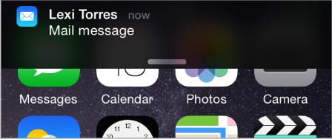

A *banner* is a small translucent view that appears onscreen and then disappears after a few seconds. Users can also see a version of the banner on the lock screen and in the Notifications view of Notification Center. In the banner, iOS displays your notification message and the small version of your app icon (to learn more about the small app icon, see [App Icon](https://developer.apple.com/library/ios/documentation/UserExperience/Conceptual/MobileHIG/AppIcons.html#//apple_ref/doc/uid/TP40006556-CH19-SW1)). Users tap the banner to dismiss it and switch to the app that sent the notification.

In addition to a default action that users can take by tapping a banner, you can also define two actions that are revealed when users swipe the banner. Tapping a notification action button dismisses the banner and launches your app (possibly in the background) to handle the action.

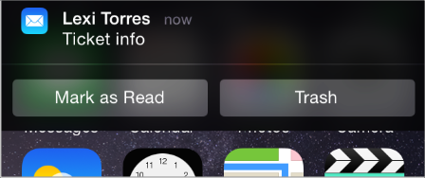

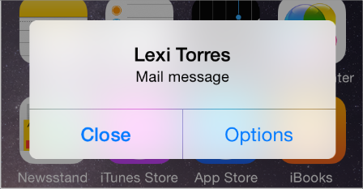

A notification *alert* is a standard alert view that appears onscreen and requires user interaction to dismiss. You supply the notification message and either a default action or up to four specific actions that are revealed when users tap the Options button. You have no control over the background appearance of the alert.

When users tap a default or custom action button in an alert, iOS simultaneously dismisses the alert and launches your app (possibly in the background). Tapping the Close or OK button dismisses the alert without opening your app.

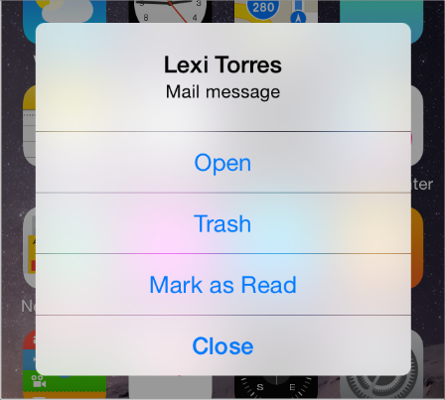

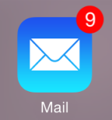

A *badge* is a small red oval that displays the number of pending notification items (a badge appears over the upper-right corner of an app’s icon). You have no control over the size or color of the badge.

A custom or system-provided *sound* can accompany any of the other three notification types.

**Think carefully before enabling a destructive action in a notification.** You want to be sure that users have enough context to avoid unintended consequences. To help users distinguish an action that you specify as destructive, iOS displays it in red. In some cases, it’s a good idea to require users to authenticate before your app performs a destructive action. For example, if you provide a destructive action in a banner that appears on the lock screen, you want to make sure that only the device’s owner can take that action (you’re responsible for implementing this requirement in code).

**Provide a custom title for each action button.** Create a very short title that clearly describes the action that occurs. For example, a game might use the title Play to indicate that tapping the button opens the app to a place where the user can take their turn. Make sure the title:

* Uses title-style capitalization
* Is short enough to fit in the button without truncation (be sure to test the length of localized titles, too)

**Don’t send multiple notifications for the same event.** Users can attend to notification items when they choose; the items don’t disappear until users handle them in some way. If you send multiple notifications for the same event, you fill up the Notification Center list and users are likely to turn off notifications from your app.

**Don’t include your app name in the notification message.** Your custom message is displayed in alerts and banners, and in the Notifications view of Notification Center. You don’t want to include your app’s name in your custom message because iOS automatically displays the name with your message.

To be useful, a local or remote notification message should:

* Focus on the information, not user actions. Avoid telling people which alert button to tap or how to open your app.
* Be short enough to display on one or two lines. Long messages are difficult for users to read quickly, and they can force alerts to scroll.
* Use sentence-style capitalization and appropriate ending punctuation. When possible, use a complete sentence.

NOTE

If necessary, iOS truncates your message so that it fits well in each notification delivery style; for best results, you shouldn’t truncate your message.

**Keep badge contents up to date.** It’s especially important to update the badge as soon as users have attended to the new information, so that they don’t think additional notifications have arrived. Note that setting the badge contents to zero also removes the related notification items from Notification Center.

IMPORTANT

Don’t use a badge for purposes other than notifications. Remember that users can turn off badging for your app, so you can’t be sure that they will see the content in a badge.

**Provide a sound that users can choose to hear when a notification arrives.** A sound can get people’s attention when they’re not looking at the device screen. For example, a calendar app might play a sound with an alert that reminds people about an imminent event. Or, a collaborative task management app might play a sound with a badge update to signal that a remote colleague has completed an assignment.

You can supply a custom sound, or you can use a built-in alert sound. If you create a custom sound, be sure it’s short, distinctive, and professionally produced. (To learn about the technical requirements for this sound, see [Preparing Custom Alert Sounds](https://developer.apple.com/library/ios/documentation/NetworkingInternet/Conceptual/RemoteNotificationsPG/Chapters/IPhoneOSClientImp.html#//apple_ref/doc/uid/TP40008194-CH103-SW6).) Note that you can’t programmatically cause the device to vibrate when a notification is delivered, because the user has control over whether alerts are accompanied by vibration.

Multitasking

Multitasking allows people to switch quickly among recently used apps.

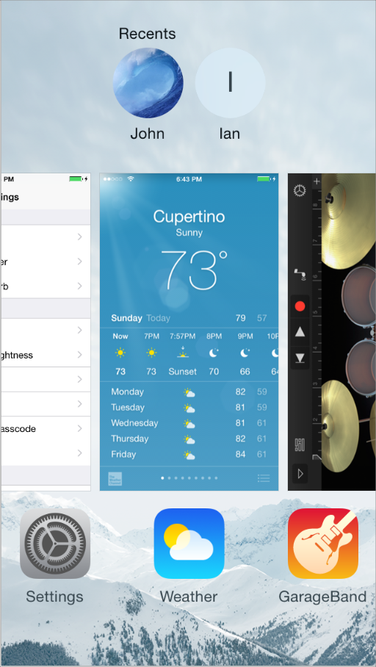

To support this experience, multitasking allows an app to enter a suspended state in the background when users switch away from it. When users switch back to the app, the app can resume quickly because it doesn’t have to reload its UI. People use the *multitasking UI* (shown above) to choose a recently used app.

API NOTE

To learn how to support multitasking in your code, see [Strategies for Handling App State Transitions](https://developer.apple.com/library/ios/documentation/iPhone/Conceptual/iPhoneOSProgrammingGuide/StrategiesforHandlingAppStateTransitions/StrategiesforHandlingAppStateTransitions.html#//apple_ref/doc/uid/TP40007072-CH8).

Thriving in a multitasking environment hinges on achieving a harmonious coexistence with other apps on the device. At a high level, this means that all apps should:

* Handle interruptions or audio from other apps gracefully
* Stop and restart—that is, transition to and from the background—quickly and smoothly
* Behave responsibly when not in the foreground

The following specific guidelines help your app succeed in the multitasking environment.

**Be prepared for interruptions, and be ready to resume.** Multitasking increases the probability that a background app will interrupt your app. Other features, such as the presence of ads and faster app-switching, can also cause more frequent interruptions. The more quickly and precisely you can save the current state of your app, the faster people can relaunch it and continue from where they left off. To give users a seamless restart experience, take advantage of UIKit’s state preservation and restoration functionality (for more information, see [Preserving Your App’s Visual Appearance Across Launches](https://developer.apple.com/library/ios/documentation/iPhone/Conceptual/iPhoneOSProgrammingGuide/StrategiesforImplementingYourApp/StrategiesforImplementingYourApp.html#//apple_ref/doc/uid/TP40007072-CH5-SW2)).

**Make sure your UI can handle the double-high status bar.** The double-high status bar appears during events such as in-progress phone calls, audio recording, and tethering. In unprepared apps the extra height of this bar can cause layout problems. For example, the UI can become pushed down or covered. In a multitasking environment, it’s especially important to be able to handle the double-high status bar properly because there are likely to be more apps that can cause it to appear.

**Be ready to pause activities that require people’s attention or active participation.** For example, if your app is a game or a media-viewing app, make sure your users don’t miss any content or events when they switch away from your app. When people switch back to a game or media viewer, they want to continue the experience as if they’d never left it.

**Ensure that your audio behaves appropriately.** Multitasking makes it more likely that other media activity is occurring while your app is running. It also makes it more likely that your audio will have to pause and resume to handle interruptions. For specific guidelines that help you make sure your audio meets people’s expectations and coexists properly with other audio on the device, see [Sound](https://developer.apple.com/library/ios/documentation/UserExperience/Conceptual/MobileHIG/Sound.html#//apple_ref/doc/uid/TP40006556-CH44-SW1).

**Use local notifications sparingly.** An app can arrange for local notifications to be sent at specific times, whether the app is suspended, running in the background, or not running at all. For the best user experience, avoid pestering people with too many notifications, and follow the guidelines for creating notification content described in [Notifications](https://developer.apple.com/library/ios/documentation/UserExperience/Conceptual/MobileHIG/NotificationCenter.html#//apple_ref/doc/uid/TP40006556-CH39-SW1).

**When appropriate, finish user-initiated tasks in the background.** When people initiate a task, they usually expect it to finish even if they switch away from your app. If your app is in the middle of performing a user-initiated task that does not require additional user interaction, you should complete it in the background before suspending.

Social Media

People expect to have access to their favorite social media accounts regardless of their current context. iOS makes it easy to integrate social media interactions into your app in ways that people appreciate.

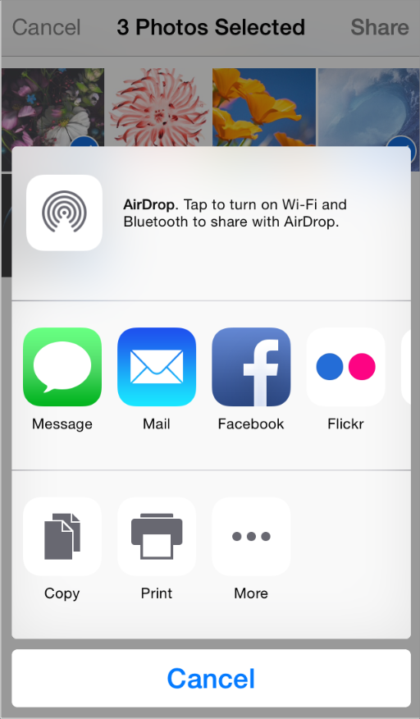

NOTE

When users tap the Action button, they get an activity view controller like the one shown here. To learn more about this view controller, see [Activity View Controller](https://developer.apple.com/library/ios/documentation/UserExperience/Conceptual/MobileHIG/ContentViews.html#//apple_ref/doc/uid/TP40006556-CH13-SW121).

The middle row of the activity view controller lists the Share app extensions enabled by the user along with system-provided sharing services. To learn more about designing a Share extension, see [Share and Action Extensions](https://developer.apple.com/library/ios/documentation/UserExperience/Conceptual/MobileHIG/AppExtensions.html#//apple_ref/doc/uid/TP40006556-CH67-SW3).

**Consider giving users a convenient way to compose a post within your app.** Users are likely to enable Share extensions that make it easy to post content from anywhere, but you can also use the system-provided compose view controller to present users with a view in which they can edit a post. Optionally, you can prepopulate the compose view with custom content before you present it to users for editing (after you present the view to users, only they can edit the content). To learn about the programming interfaces of the Social framework—including the[SLComposeViewController](https://developer.apple.com/library/ios/documentation/NetworkingInternet/Reference/SLComposeViewController_Class/index.html#//apple_ref/occ/cl/SLComposeViewController) class—see [*Social Framework Reference*](https://developer.apple.com/library/ios/documentation/Social/Reference/Social_Framework/index.html#//apple_ref/doc/uid/TP40012233).

**When possible, avoid asking users to sign into a social media account.** The Social framework works with the Accounts framework to support a single sign-on model, so you can get authorization to access the user’s account without asking them to reauthenticate. If the user hasn’t already signed into an account, you can present UI that allows them to do so.

iCloud

iCloud lets people access the content they care about regardless of which device they’re currently using. When you integrate iCloud into your app, users can use different instances of your app on different devices to view and edit their personal content without performing explicit synchronization.

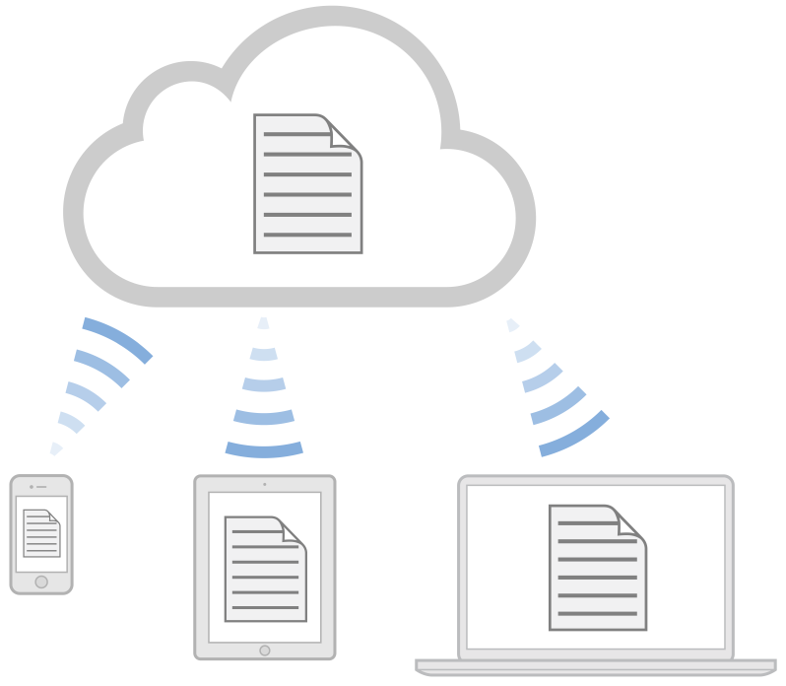

To provide this user experience, it’s likely that you’ll need to reexamine the ways in which you store, access, and present information—especially user-created content—in your app. To learn how to enable iCloud in your app, see [*iCloud Design Guide*](https://developer.apple.com/library/ios/documentation/General/Conceptual/iCloudDesignGuide/Chapters/Introduction.html#//apple_ref/doc/uid/TP40012094).

A fundamental aspect of the iCloud user experience is transparency: Ideally, users don’t need to know where their content is located and they should seldom have to think about which version of the content they’re currently viewing. The following guidelines can help you give users the iCloud experience they’re expecting.

**If appropriate, make it easy for users to enable iCloud for your app.** On their iOS devices, users log into their iCloud account in iCloud Settings, and for the most part, they expect their apps to work with iCloud automatically. But if you think users might want to choose whether to use iCloud with your app, you can provide a simple option that they can set when they open your app for the first time. In most cases, this option should provide a choice between using iCloud with all the content that users access in your app or not at all.

**Respect the user’s iCloud space.** It’s important to remember that iCloud is a finite resource for which users pay. You should use iCloud for storing information that users create and understand, and avoid using it to store app resources or content that you can regenerate. Also, note that when the user’s iCloud account is active, iCloud automatically backs up the contents of your app’s Documents folder. To avoid using up too much of the user’s space, it’s best to be picky about the content you place in the Documents folder.

**Avoid asking users to choose which documents to store in iCloud.** Typically, users expect all the content they care about to be available via iCloud. Most users don’t need to manage the storage of individual documents, so you shouldn’t assume that your app needs to support this experience. To provide a good user experience, you might want to rearchitect the way your app handles and exposes content so that you can perform more file-management tasks for the user.

**Determine which types of information to store in iCloud.** In addition to storing user-created documents and other content, you can also store small amounts of data such as the user’s current state in your app or their preferences. To store this type of information you use iCloud key-value storage. For example, if people use your app to read a magazine, you might use iCloud key-value storage to store the last page they viewed so that when they reopen the issue on a different device, they can continue reading from where they left off.

If you use iCloud key-value storage to store preferences, be sure that the preferences are ones that users are likely to want to have applied to all their devices. For example, some preferences are more useful in a work environment than they are in a home environment. In some cases, it can make sense to store preferences on your app’s server, instead of in the user’s iCloud account, so that the preferences are available regardless of whether iCloud is enabled.

**Make sure that your app behaves reasonably when iCloud is unavailable.** For example, if users log out of their iCloud account, turn off iCloud usage for your app, or enter Airplane mode, iCloud becomes unavailable. In these cases, users performed an action that turned off access to iCloud, so your app does not need to tell them about it. However, it can be appropriate to show users that the changes they make will not be visible on their other devices until they restore access to iCloud.

**Avoid giving users the option to create a "local” document.** Regardless of whether you support iCloud in your app, you should not encourage users to think in terms of a device-specific file system. Instead, you want users to focus on the pervasive availability of their content through iCloud.

**When appropriate, update content automatically.** It’s best when users don’t have to take any action to ensure that they’re accessing the most up-to-date content in your app. However, you need to balance this experience with respect for the user’s device space and bandwidth constraints. If your users work with very large documents, it can be appropriate to give them control over whether to download an update from iCloud. If you need to do this, design a way to indicate that a more recent version of the document is available in iCloud. When the user chooses to update the document, be sure to provide subtle feedback if the download takes more than a few seconds.

**Warn users about the consequences of deleting a document.** When a user deletes a document in an iCloud-enabled app, the document is removed from the user’s iCloud account and all other devices. It’s appropriate to display an alert that describes this result and to get confirmation before you perform the deletion.

**Tell users about conflicts as soon as possible, but only when necessary.** Using the iCloud programming interfaces, you should be able to resolve most conflicts between different versions of a document without involving the user. In cases where this is not possible, make sure that you detect conflicts as soon as possible so that you can help users avoid wasting time on the wrong version of their content. You need to design an unobtrusive way to show users that a conflict exists; then, make it easy for users to differentiate between versions and make a decision.

**Be sure to include the user’s iCloud content in searches.** Users with iCloud accounts tend to think of their content as being universally available, and they expect search results to reflect this perspective. If your app allows people to search their content, make sure you use the appropriate APIs to extend search to their iCloud accounts.

HealthKit

In iOS 8 and later, apps built with HealthKit can use data from the Health app to provide health and fitness services that are more powerful and integrated. With the user’s permission, apps can use HealthKit to both read and write data from the Health app, the central storage location for a user’s health-related data.

For example, users can give a nutrition app access to the weight and activity data they store in the Health app so that the nutrition app can recommend the number of calories to consume each day to reach a certain goal. The nutrition app can also use HealthKit to update the Health app with the number of calories actually consumed, so that users can more easily track their progress. To learn how to integrate HealthKit into your app, see [*HealthKit Framework Reference*](https://developer.apple.com/library/ios/documentation/HealthKit/Reference/HealthKit_Framework/index.html#//apple_ref/doc/uid/TP40014707).

The following guidelines can help you create a health and fitness app that people trust and enjoy using.

**Request access to health data only if you have a compelling reason to do so.** HealthKit is designed for use in apps focused on health and fitness services. If an app asks for access to unrelated health information, users are less likely to trust the app with their private data. So it’s your job to make sure that users understand the reasons your app needs access to specific pieces of their private health data and the benefits of sharing that data.

**Avoid asking for health data before users have a chance to understand what it will be used for.** People are more inclined to give access to their health data if they see the connection between their current task and your request for the data. For example, when users are filling out a profile in a weight-loss app, it makes sense to ask for access to the weight data they store in the Health app. But if the weight-loss app asks for access to weight data immediately after the app launches, users may be less inclined to share their private information.

**Use the system-provided UI to request permission to access the user’s data.** Users expect to see the system-provided permission sheet, as shown here, as soon as they need to grant permission to access their data. To provide a good user experience, avoid duplicating information from the permission sheet in your app’s other screens. Instead, you can add customized messages to the permission sheet to explain why your app needs to access specific pieces of data (for more information, see [*HKHealthStore Class Reference*](https://developer.apple.com/library/ios/documentation/HealthKit/Reference/HKHealthStore_Class/index.html#//apple_ref/doc/uid/TP40014708)). Keep these messages brief, but make sure that they clearly convey how your app uses the health data and the benefits of sharing it.

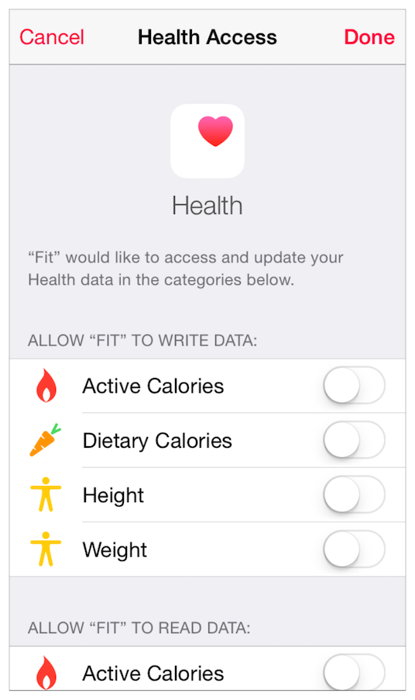

NOTE

If users decide to stop sharing data with your app, they make this change in Settings. There is no need to enable this action within the UI of your app.

**Don't use Health app icons, images, or screenshots in your UI.** As with all Apple designs, these images are copyrighted and should not be displayed in your app.

**Don't use the term “HealthKit” in your UI.** HealthKit is a developer term that names the technical framework you use to access data stored in the Health app. If you need to refer to the ways in which your app works with the data users store in the Health app, use the term “the Health app.” For example, you might say that your app “saves information to the Health app” or “uses data from the Health app.”

Passbook

The Passbook app helps people view and manage passes, which are digital representations of physical items such as boarding passes, coupons, membership cards, and tickets. In your app, you can create a pass, distribute it to users, and update it when things change.

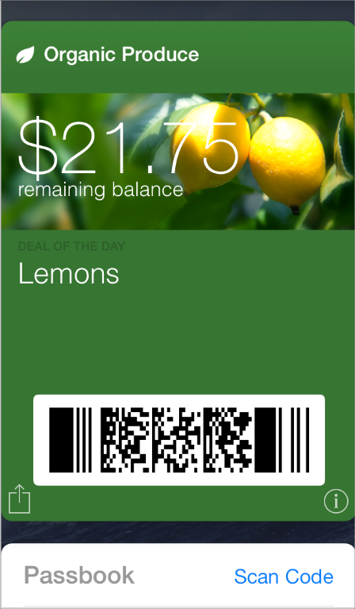

The PassKit framework makes it easy to use custom content to assemble a pass and to access a pass when it’s in the user’s pass library. (To learn about the key concepts of Passbook technology and how to use the PassKit APIs in your app, see [*Passbook Programming Guide*](https://developer.apple.com/library/ios/documentation/UserExperience/Conceptual/PassKit_PG/Chapters/Introduction.html#//apple_ref/doc/uid/TP40012195).) The following guidelines can help you create a pass that people appreciate having in their pass library and enjoy using.

**As much as possible, avoid simply reproducing an existing physical pass.** Passbook has an established design aesthetic and passes that coordinate with this aesthetic tend to look best. Instead of replicating the appearance of a physical item, take this opportunity to design a clean, simple pass that follows the form and function of Passbook.

**Be selective about the information you put on the front of a pass.** People expect to be able to glance at a pass and quickly get the information they need, so the front of a pass should be uncluttered and easy to read. If there’s additional information that you think people might need, it’s better to put it on the back of the pass than to squeeze it onto the front.

**In general, avoid using a plain white background.** A pass tends to look best when its background is a vivid, solid color or displays an image that uses strong, vibrant colors. As you design the background, always make sure that it doesn’t interfere with the readability of the content.

**Use the logo text field for your company name.** Text in the logo text field is rendered in a consistent font on all passes. To avoid clashing with other passes in the user’s pass library, it’s recommended that you enter text into the logo text field instead of using a custom font.

NOTE

It’s best to use the appropriate pass fields for all of the text in your pass and avoid embedding text in images or using custom fonts. Using the fields benefits you in two important ways: It allows VoiceOver users to get all the information in your pass and it gives your pass a consistent appearance.

**Use a white company logo.** The logo image is placed in the upper-left corner of the pass, next to your company name. For best results, supply a white, monochrome version of your logo that doesn’t include text. If you want to engrave the logo so that it matches the rendered logo text, add a black drop shadow with a 1 pixel y offset, a 1 pixel blur, and 35% opacity.

**Use a rectangular barcode when possible.** Because of the layout of a pass, a rectangular barcode—such as PDF417—tends to look better than a square barcode. As shown below on the right, a square barcode creates empty gutters on both sides and can vertically crowd the fields above and below it.

A rectangular barcode fits well in the layout



A square barcode can crowd other fields



**Optimize images for performance.** Because users often receive passes via email or Safari, it’s important to make downloads as fast as possible. To improve the user experience, use the smallest image files that achieve the desired visual appearance.

**Enhance the utility of a pass by updating it when appropriate.** Even though a pass represents a physical item that doesn’t typically change, your digital pass can provide a better experience by reflecting real-world events. For example, you can update an airline boarding pass when a flight is delayed so that people always get current information when they check the pass.

Apple Pay

Apple Pay is an easy, secure, and private way to make payments on iOS devices. When purchasing physical goods and services in apps, people can use Apple Pay to quickly and securely provide their contact, shipping, and payment information.

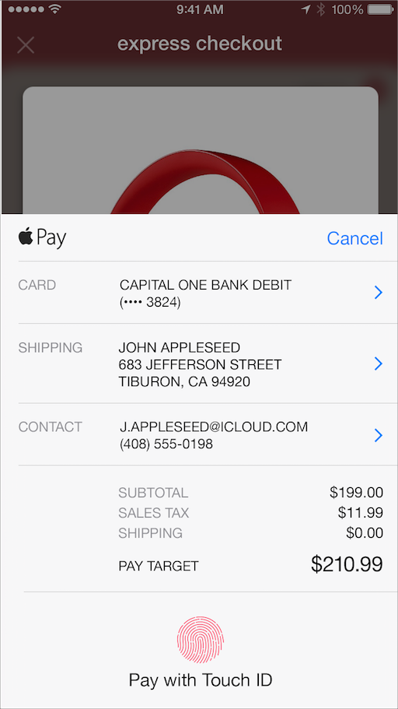

With Apple Pay, users can make purchases without having to create an account or type their information. Apple Pay significantly expedites the checkout process, helping to eliminate up-front registration and providing users with a better experience for browsing your products and making hassle-free purchases. For more information, see [*Apple Pay Programming Guide*](https://developer.apple.com/library/ios/ApplePay_Guide/index.html#//apple_ref/doc/uid/TP40014764).

The Apple Pay UI is clear, streamlined, and unobtrusive. It consists of three pieces that appear in different contexts:



**Button.** The Apple Pay button indicates that users can make a purchase from their immediate context, such as a product page. When users tap the Apple Pay button, they should see the payment sheet and begin their checkout process. (For more information on using the Apple Pay button, see [*PKPaymentButton Class Reference*](https://developer.apple.com/library/ios/documentation/PassKit/Reference/PKPaymentButton_Class/index.html#//apple_ref/doc/uid/TP40015149).)

**Payment mark.** Users expect to see the Apple Pay payment mark when they need to select a payment option and finalize additional information before authorizing a payment. The payment mark should appear only when other payment options are also displayed in the same or similar format.



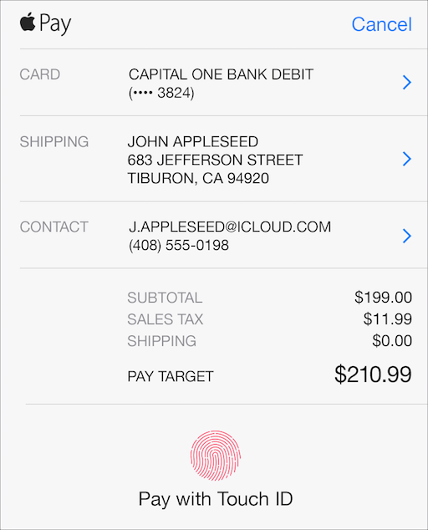

**Payment sheet.** Before a user submits an order and the associated payment, Apple Pay displays a payment sheet with the contact, shipping, and payment information relevant to their checkout. Although people can make some changes in the payment sheet—such as selecting a different shipping method—they shouldn’t have to make changes or enter additional information. When users see the payment sheet, they should be able to immediately complete their transaction and authorize a payment.

**Don’t display any Apple Pay UI if a user can’t use Apple Pay.** If someone doesn’t have an authenticated card set up or is using a device that doesn’t support Apple Pay, advertising it as a payment option will probably confuse and mislead them. In addition, avoid prompting people to set up Apple Pay if they haven’t done so.

**Display the payment sheet immediately after a user taps the Apple Pay button.** Including additional steps after users have decided to begin their checkout with Apple Pay adds more friction to completing the payment, which can complicate the checkout process and frustrate people. Avoid displaying additional alerts or modal views after a user taps the Apple Pay button.

**Display the Apple Pay button at the same size or larger than other visible payment buttons.** Show the Apple Pay button prominently to help users find it with ease.

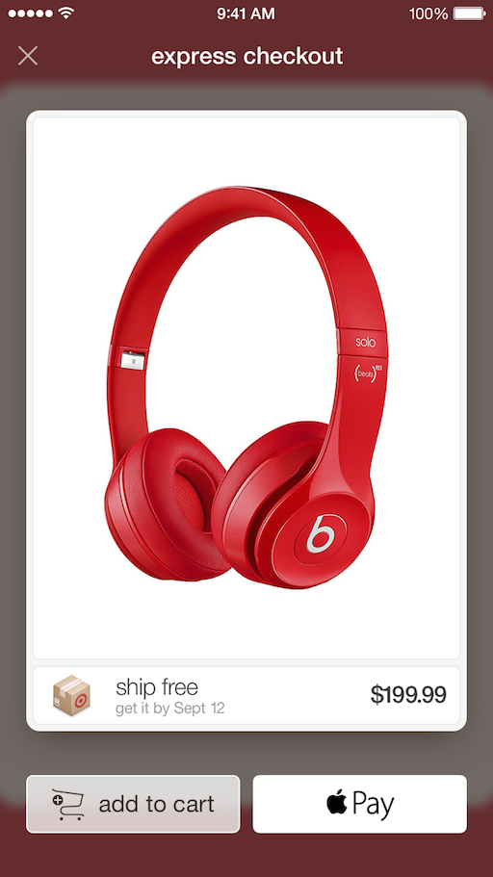

For additional guidelines on how to use Apple Pay buttons and payment marks, see [Apple Pay Identity Guidelines](https://developer.apple.com/apple-pay/Apple-Pay-Identity-Guidelines.pdf).

Customizing the Payment Sheet

You can customize what the Apple Pay payment sheet displays depending on the information you need to know to complete the transaction and the information you need to convey to the user about the purchase.

**Make sure to display only the information that’s necessary to complete the transaction on the payment sheet.** Users may get confused or concerned if the Apple Pay payment sheet displays extraneous information. For example, if the merchandise will be delivered or fulfilled electronically, it makes sense to request a contact email address, but not a shipping address. Requesting a shipping address in this case may give users the impression that something will be shipped to their home or work by accident, or cause them concern about their information being accessed needlessly.

**Let users choose their delivery method within the payment sheet.** Users can select a delivery method from any number of methods that you specify within the Apple Pay payment sheet. To specify a shipping method, use a label, a cost, and an optional second line for providing an estimated date of delivery.

**Use line items for recurring payments and for charges that are added to the merchandise being purchased.** A line item consists of a label and a cost. It conveys additional information about the breakdown of charges in the user’s purchase. Use line items to:

* Indicate that a user is authorizing a recurring payment with a line item like “Monthly Subscription $19.99”
* Notify the user of extra charges, for example, “Gift Wrap $5.00” or “Tax $4.53”
* Show a coupon or discount that has a negative cost, such as “Friday Discount -$2.00”

Avoid using line items to show an itemized list of products.

**As much as possible, create line item labels that can display on a single line.** Line item labels should be specific and easily understood by users. Creating lengthy labels makes it difficult for your users to understand line items at a glance.

**Provide a business name after the word “PAY” on the same line as the total.** This helps reassure users that their payment is going where they think it’s going.

**Make sure to communicate that there might be additional costs if the total cost is unknown at the time the payment is authorized.** Users can authorize Apple Pay payments for services without knowing the exact total amount. For example, car rides based on distance or time might change in value from the time when a payment is authorized to the time when it’s posted. As another possibility, a customer might want to add a tip after their product has been delivered. In these cases, it’s important to explain this clearly within the payment sheet. Use a line item to explain that there might be additional costs, or add text after the business name so that users understand that the total is an estimate. If you are preauthorizing a payment for a specific amount, make sure the payment sheet accurately reflects this information.

Streamlining the Checkout Process

People appreciate using Apple Pay to make their purchases quickly and easily. The fewer steps in the checkout process and the less information that users have to enter manually, the better.

**Always use the latest information from Apple Pay.** Assume that users keep their Apple Pay information complete and up to date, and don’t rely on any previously collected information. Even if you previously collected contact, shipping, or payment information from users, fetch the latest information from Apple Pay during checkout. Avoid making people enter any information during checkout that you could have retrieved from Apple Pay.

**Use Apple Pay to accept single-item purchases if your app doesn’t have a shopping cart.**To make a single-item purchase, let users tap the Apple Pay button on a product page to display the payment sheet and proceed with an immediate checkout.

**Use Apple Pay to offer an express checkout.** If your app has a shopping cart and all of the merchandise in that cart must be shipped by the same method to the same address, offer an express checkout using Apple Pay. Display the payment sheet as soon as users are ready to pay for their merchandise, because all of the information needed for the purchase can be set or adjusted within the payment sheet.

Depending on your app’s checkout experience, you may need to collect additional information before beginning the Apple Pay checkout process. When you do, be sure to collect the right information before displaying the payment sheet, and then let the payment sheet take care of the rest.

**Let users specify different shipping methods or different addresses before displaying the payment sheet.** If your app has a shopping cart and offers the ability to ship individual items by different shipping methods or to different addresses, give people a means of entering this information before displaying the Apple Pay payment sheet. Although there is no way to specify multiple shipping methods or addresses in the payment sheet, you should still use Apple Pay to get payment information.

**Let users specify additional information for in-store pickup before displaying the payment sheet.** If your app offers an in-store pickup as a delivery option, give people a means of entering relevant information before displaying the payment sheet, including:

* A name, in case the person picking up the order isn’t the same as the person placing the order
* A store location (if you need the user to select the store location for pick-up, use Location Services to show them the closest store and have them select one before displaying the payment sheet)

**Make sure to collect redemption codes for discounts before displaying the payment sheet.** Because there’s no way to input codes within the Apple Pay payment sheet, be sure to collect any codes before displaying the sheet.

**Display an order confirmation or thank you page.** To provide a clear user experience, after the payment is complete, use an order confirmation page to display details about when the merchandise will ship and how users can check the status of their order.

**If appropriate, note Apple Pay on your confirmation page.** Although it’s not necessary to mention Apple Pay on your confirmation screen, if you choose to, use one of these formats:

* “Visa ••••1234 (Apple Pay)”
* “Paid with Apple Pay”

## In-App Purchase

In-App Purchase lets people buy digital products within your app, in a store that you design.

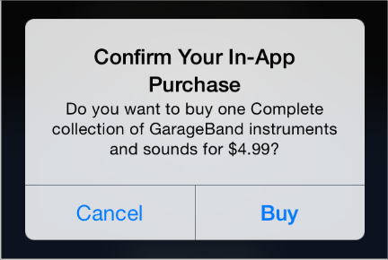

For example, users might:

* Upgrade a basic version of an app to a premium version
* Renew a subscription for new monthly content
* Purchase virtual items, such as a new level or weapon in a game
* Buy and download new books

You use the StoreKit framework to embed a store in your app and support In-App Purchase. When a user makes a purchase, StoreKit connects to the App Store to securely process the payment and then notifies your app so that it can provide the purchased item.

IMPORTANT

In-App Purchase only collects payment—you provide additional functionality, such as presenting your store to users, unlocking built-in features, and downloading content from your own servers. Also, all products you sell through In-App Purchase must be registered in the App Store.

To learn about the technical requirements of adding a store to your app, see [*In-App Purchase Programming Guide*](https://developer.apple.com/library/ios/documentation/NetworkingInternet/Conceptual/StoreKitGuide/Introduction.html#//apple_ref/doc/uid/TP40008267). For more information on the business requirements of using In-App Purchase, visit the [App Store Resource Center](http://developer.apple.com/appstore/). You should also read your licensing agreement for definitive information about what you may sell and how you are required to provide those products in your app.

The following guidelines can help you design a purchasing experience that users appreciate.

**Elegantly integrate the store experience into your app.** When presenting products and handling user transactions, create an experience that feels at home in your app. You don’t want users to think that they’ve entered a different app when they visit your store.

**Use simple, succinct titles and descriptions.** It’s best when people can scan a set of items and quickly find the ones they’re interested in. When you use plain, direct language and titles that don’t truncate or wrap, it’s easier for people to understand the items you’re offering.

**Don’t alter the default confirmation alert.** When users buy a product, StoreKit presents a confirmation alert (shown above). You shouldn’t modify this alert because it helps users avoid accidental purchases.

## Game Center

Game Center lets people play games, organize online multiplayer games, and more. Players use the built-in Game Center app to sign in to an account, discover new games, add new friends, and browse leaderboards and achievements.

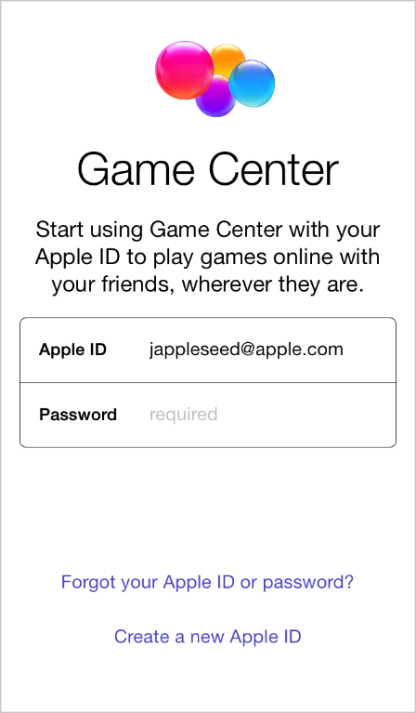

As a game developer, you use the GameKit APIs to post scores and achievements to the Game Center service, display leaderboards in the game UI, and help users find other players. To learn how to integrate Game Center into your app, see [*Game Center Programming Guide*](https://developer.apple.com/library/ios/documentation/NetworkingInternet/Conceptual/GameKit_Guide/Introduction/Introduction.html#//apple_ref/doc/uid/TP40008304).

The following guidelines can help you give people a great Game Center experience in your app.

**Don’t create custom UI that prompts users to sign into Game Center.** When people start your Game Center-enabled app—and they’re not already signed into Game Center on their device—the system automatically prompts them to sign in. Displaying custom sign-in UI is unnecessary and might confuse users.

**In general, use the standard Game Center UI.** In rare cases, it might make sense for a game to customize the Game Center UI, but doing so risks confusing people. The standard Game Center UI—which is familiar to both iOS and OS X users—promotes the sense of belonging to a larger gaming community.

**Give users the ability to turn off voice chat.** Some users might not want voice chat to be on automatically when they start your game, and most users appreciate the ability to turn off voice chat in certain situations.

## iAd Rich Media Ads

When you allow advertisements to appear in your app, you can receive revenue when users see or interact with them. (Here you can see a placeholder for an iAd banner in a sample project.)

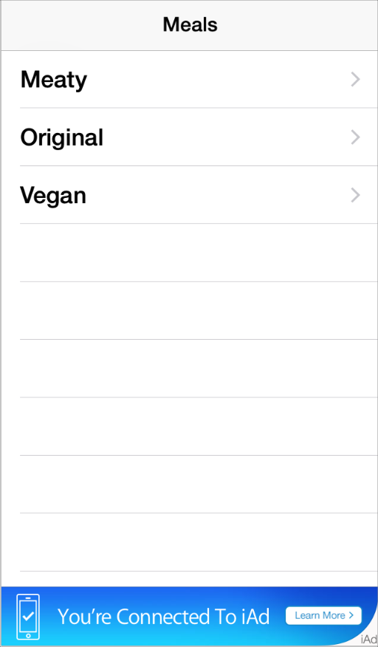

You host an ad served by the iAd Network in a specific view in your UI. Initially, this view can contain the ad’s banner, which functions as the entrance into the full iAd experience. When people tap the banner, the ad performs a preprogrammed action, such as playing a movie, displaying interactive content, or launching Safari to open a webpage. The action can display content that covers your UI or it can cause your app to transition to the background.

There are three types of banners that you can display in your app: standard, medium rectangle, and full screen. All types of banners serve the same purpose—that is, to usher users into the ad—but they differ in their appearance and behavior.

A standard banner takes up a small area of the screen and is often visible for as long as the screen is visible. You choose the app screens that should display a standard banner and make room for the banner view in the layout.

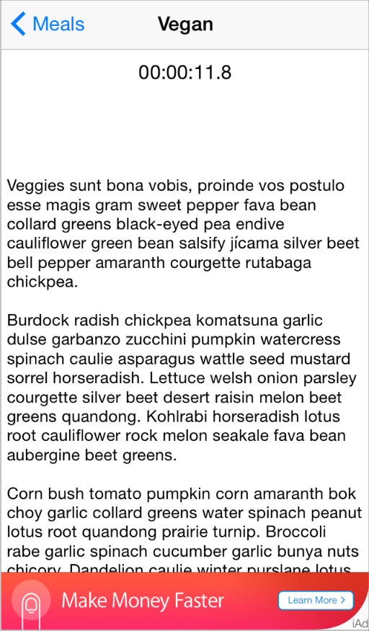

All iOS apps can display standard banners. Use a view provided by the [ADBannerView](https://developer.apple.com/library/ios/documentation/UserExperience/Reference/ADBannerView_Ref/index.html#//apple_ref/occ/cl/ADBannerView) class to contain a standard banner in your app.

A medium rectangle banner is similar in behavior to a standard banner and—as with standard banners—you choose where a medium rectangle banner should be displayed.

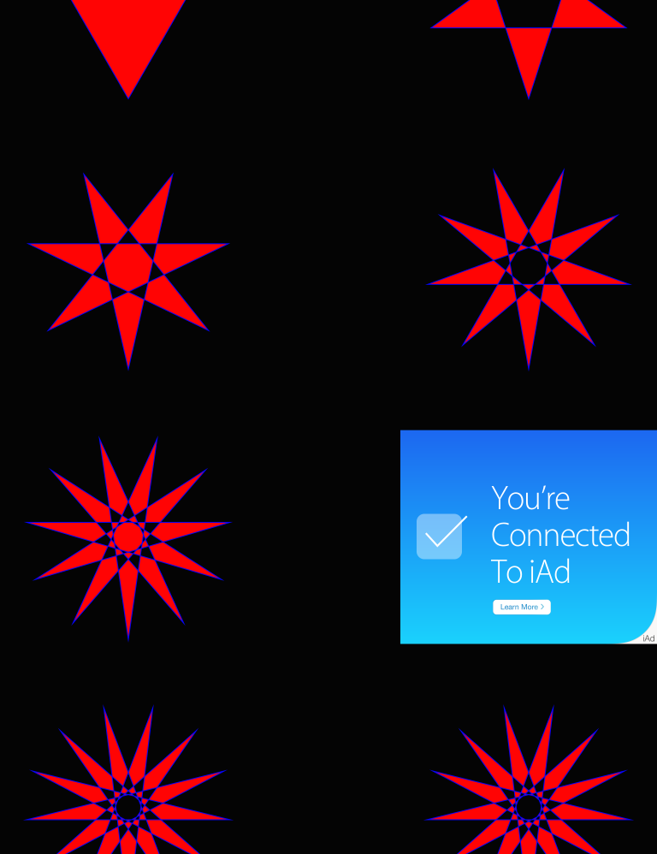

Medium rectangle banners are available only in iPad apps. You use a view provided by the[ADBannerView](https://developer.apple.com/library/ios/documentation/UserExperience/Reference/ADBannerView_Ref/index.html#//apple_ref/occ/cl/ADBannerView) class to contain a medium rectangle banner in your app.

A full screen banner occupies most or all of the screen and is usually visible at specific times during the app flow or in specific locations. You choose whether to display the banner modally or as a separate page within scrollable content. (In the example shown here, the app provides a magazine-reading experience and lets users turn the page away from or back to the full screen banner.)



Use a view provided by the [ADInterstitialAd](https://developer.apple.com/library/ios/documentation/iAd/Reference/ADInterstitialAd_Ref/index.html#//apple_ref/occ/cl/ADInterstitialAd) class to contain a full screen banner in your app.

All banner types appear inside the iAd frame, which displays the iAd mark in the lower-right corner. The iAd frame has been designed to look best when it is anchored to the bottom edge of your app screens.

To ensure seamless integration with banner ads and to provide the best user experience, follow these guidelines.

**Place a standard banner view at or near the bottom of the screen.** This placement differs slightly, depending on whether there is a bar at the bottom of the screen and if so, the kind of bar.

| Bar | Standard banner view placement |
| --- | --- |
| No bar at the bottom of the screen | At the bottom of the screen |
| No bars anywhere on the screen | At the bottom of the screen |
| Toolbar or tab bar | Directly above the bottom bar |

**Place a medium rectangle banner view where it doesn’t interfere with the user’s content.**As with the standard banner view, the medium banner view looks best at or near the bottom of the screen. Putting the banner near the bottom of the screen also increases the likelihood that it won’t get in people’s way.

**Present a full screen banner modally when there are interludes in the user experience.** If there are natural breaks or context changes in the flow of your app, the modal presentation style can be appropriate. When you present a full screen banner modally (by using[presentFromViewController:](https://developer.apple.com/library/ios/documentation/iAd/Reference/ADInterstitialAd_Ref/index.html#//apple_ref/occ/instm/ADInterstitialAd/presentFromViewController:)), the user must either enter the ad or dismiss it. For this reason, it’s a good idea to use the modal presentation style when users are expecting a change in experience, such as after they complete a task.

**Present a full screen banner nonmodally when there are transitions between app views.** If users experience your app by making frequent screen transitions, such as paging through a magazine or flicking through a gallery of items, the nonmodal presentation style can be appropriate. When you present a full screen banner nonmodally (by using [presentInView:](https://developer.apple.com/library/ios/documentation/iAd/Reference/ADInterstitialAd_Ref/index.html#//apple_ref/occ/instm/ADInterstitialAd/presentInView:)), you can preserve the bars in your UI so that users can use app controls to move past or return to the ad. As with all banners, a full screen banner launches the iAd experience when a user taps it, but your app can respond to other gestures within the banner area (such as drag or swipe) if appropriate.

Be sure to use appropriate animations to reveal and hide a nonmodal full screen banner view. For example, a magazine reader app would probably present a banner using the same page-turn animation it uses to reveal other content pages.

**Ensure that all banners appear when and where it makes sense in your app.** People are more likely to enter the iAd experience when they don’t feel like they’re interrupting their workflow to do so. This is especially important for immersive apps such as games: You don’t want to place banner views where they will conflict with playing a game.

**Avoid displaying banners on screens that users are likely to see only briefly.** If your app includes screens that users move through quickly as they drill down or navigate to the content they care about, it’s best to avoid displaying banners on these screens. Users are more likely to tap a banner when it stays onscreen for more than a second or two.

**As much as possible, display banner ads in both orientations.** It’s best when users don’t have to change the orientation of the device to switch between using your app and viewing an ad. Also, supporting both orientations allows you to accept a wider range of advertisements. To learn how to make sure a banner view responds to orientation changes, see [*iAd Programming Guide*](https://developer.apple.com/library/ios/documentation/UserExperience/Conceptual/iAd_Guide/Introduction/Introduction.html#//apple_ref/doc/uid/TP40009881).

**Don’t allow standard or medium rectangle banners to scroll off the screen.** If your app displays scrolling content in the screen, make sure the banner view remains anchored in its position.

**While people view or interact with ads, pause activities that require their attention or interaction.** When people choose to view an ad, they don’t want to feel that they’re missing events in your app, and they don’t want your app to interrupt the ad experience. A good rule of thumb is to pause the same activities you would pause when your app transitions to the background.

**Don’t stop an ad, except in rare circumstances.** In general, your app continues running and receiving events while users view and interact with ads, so it’s possible that an event will occur that urgently requires their immediate attention. However, there are very few scenarios that warrant the dismissal of an in-progress ad. One possibility is with an app that provides Voice over Internet Protocol (VoIP) service. In such an app, it probably makes sense to cancel a running ad when an incoming call arrives.

NOTE

Canceling an ad might adversely impact the kinds of advertisements your app can receive and the revenue you can collect.

## AirPrint

Using AirPrint, people can wirelessly print content from your app and use Print Center app to check on a print job.

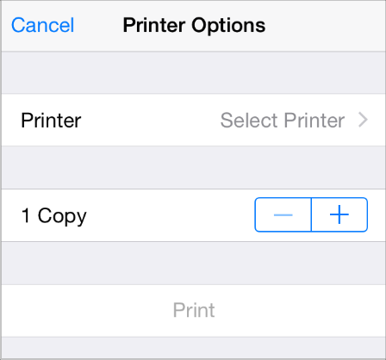

You can take advantage of built-in support for printing images and PDF content, or you can use printing-specific programming interfaces to do custom formatting and rendering. iOS handles printer discovery and the scheduling and execution of print jobs on the selected printer.

Typically, users tap the standard Action button in your app when they want to print something. When they choose the Print item in the view that appears, they can then select a printer, set available printing options, and tap the Print button to start the job.

Users can check on the print job they requested in the Print Center app, which is a background system app that is available only while a print job is in progress. In Print Center, users can view the current print queue, get details about a specific print job, and even cancel the job.

You can support basic printing in your app with comparatively little additional code (to learn about adding print support to your code, see [*Drawing and Printing Guide for iOS*](https://developer.apple.com/library/ios/documentation/2DDrawing/Conceptual/DrawingPrintingiOS/Introduction/Introduction.html#//apple_ref/doc/uid/TP40010156)). To ensure that users appreciate the printing experience in your app, follow these guidelines:

**Use the system-provided Action button.** Users are familiar with the meaning and behavior of this button, so it’s a good idea to use it when possible. The main exception to this is if your app does not contain a toolbar or navigation bar. When this is the case, you need to design a custom print button that can appear in the main UI of your app, because the Action button can only be used in a toolbar or navigation bar.

**Display the Print item when printing is a primary function in the current context.** If printing is inappropriate in the current context, or if users are not likely to want to print, don’t include the Print item in the view revealed by the Action button.

**If appropriate, provide additional printing options to users.** For example, you might allow users to choose a page range or to request multiple copies.

**Don’t display print-specific UI if users can’t print.** Be sure to check whether the user’s device supports printing before you display UI that offers printing as an option. To learn how to do this in your code, see [*UIPrintInteractionController Class Reference*](https://developer.apple.com/library/ios/documentation/UIKit/Reference/UIPrintInteractionController_Class/index.html#//apple_ref/doc/uid/TP40010141).

## Accessing User Data

Location Services allows apps to determine people’s approximate location geographically, the direction they’re pointing their device, and the direction in which they’re moving. Other system services—such as Contacts, Calendar, Reminders, and Photo Library—also allow apps to access the data people store in them.

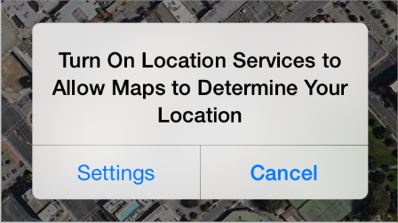

Although people appreciate the convenience of using an app that already knows a lot about them, they also expect to have the option of keeping their data private. For example, people like being able to automatically tag content with their physical location or find friends that are currently nearby, but they also want to be able to disable such features when they don’t choose to share their location with others. (To learn more about how to make your app location-aware, see [*Location and Maps Programming Guide*](https://developer.apple.com/library/ios/documentation/UserExperience/Conceptual/LocationAwarenessPG/Introduction/Introduction.html#//apple_ref/doc/uid/TP40009497).)

The following guidelines can help you ask for user data in ways that help people feel comfortable.

**Make sure users understand why they’re being asked to share their personal data.** It’s natural for people to be suspicious of a request for their personal information if they don’t see an obvious need for it. To avoid making users uncomfortable, make sure the alert appears only when they attempt to use a feature that clearly needs to know their information. For example, people can use Maps when Location Services is off, but they see an alert when they access the feature that finds and tracks their current location.

**Describe why your app needs the information, if it’s not obvious.** You can provide text that appears in the alert, below a system-provided title such as ““App Name” Would Like to Access Your Contacts” or for location notifications, “Allow “App Name” to Use Your Location While You Use the App?”. You want this text to be specific and polite so that people understand why you’re asking for access to their information and don’t feel pressured.

Your reason text should:

* Not include your app name. The system-provided alert title already includes your app name.
* Clearly describe why your app needs the data. If appropriate, you might also explain ways in which your app will not use the data.
* Use user-centric terminology and be localizable.
* Be as short as possible, while still being easy to understand. As much as possible, avoid supplying more than one sentence.
* Use sentence-style capitalization. (Sentence-style capitalization means that the first word is capitalized, and the rest of the words are lowercase unless they are proper nouns or proper adjectives.)

**Ask permission at app startup only if your app can’t perform its primary function without the user’s data.** People won’t be bothered by this if it’s obvious that the main function of your app depends on knowing their personal information.

**Avoid making programmatic calls that trigger the alert before the user actually selects the feature that needs the data.** This way, you avoid causing people to wonder why your app wants their personal information when they’re doing something that doesn’t appear to need it. (Note that checking the user’s Location Services preference does not trigger the alert.)

**For location data, check the Location Services preference to avoid triggering the alert unnecessarily.** You can use Core Location programming interfaces to get this setting (to learn how to do this, see [*Core Location Framework Reference*](https://developer.apple.com/library/ios/documentation/CoreLocation/Reference/CoreLocation_Framework/index.html#//apple_ref/doc/uid/TP40007123)). With this knowledge, you can trigger the alert as closely as possible to the feature that requires location information, or perhaps avoid an alert altogether.

## Quick Look

Using Quick Look, users can preview a document within your app, even if your app can’t open the document. For example, you might allow users to preview documents that they download from the web or receive from other sources.



To learn more about how to support Quick Look document preview in your app, see [*Document Interaction Programming Topics for iOS*](https://developer.apple.com/library/ios/documentation/FileManagement/Conceptual/DocumentInteraction_TopicsForIOS/Introduction/Introduction.html#//apple_ref/doc/uid/TP40010403).

Before users preview a document in your app, they can see information about the document in a custom view that you create. For example, after users download a document attached to an email message, Mail displays the document’s icon, title, and size in a custom view within the message. Users can tap this view to preview the document.



You can present a document preview in a new view in your app, or in a full-screen, modal view. The presentation method you choose depends on which device your app runs on.

**On iPad, display a document preview modally.** The large iPad screen is appropriate for displaying a document preview in an immersive environment that users can easily leave. The zoom transition is especially well-suited to reveal the preview.

**On iPhone, display a document preview in a dedicated view, preferably a navigation view.**Doing this allows users to navigate to and from the document preview without losing context in your app. Although it’s possible to display a document preview modally in an iPhone app, it’s not recommended. (Note that the zoom transition is not available on iPhone.)

Also, note that displaying a document preview in a navigation view allows Quick Look to place preview-specific navigation controls in the navigation bar. (If your view already contains a toolbar, Quick Look places the preview navigation controls in the toolbar, instead.)

## Sound

Whether sound is a primary part of your app’s user experience or an optional enhancement, you need to know how users expect sound to behave and how to meet those expectations.

### Understand User Expectations

People can use device controls to affect sound, and they might use wired or wireless headsets and headphones. People also have various expectations for how their actions impact the sound they hear. Although you might find some of these expectations surprising, they all follow the principle of user control in that the user, not the device, decides when it’s appropriate to hear sound.

**Users switch their devices to silent when they want to**:

* Avoid being interrupted by unexpected sounds, such as phone ringtones and incoming message sounds
* Avoid hearing sounds that are the byproducts of user actions, such as keyboard or other feedback sounds, incidental sounds, or app startup sounds
* Avoid hearing game sounds that are not essential to using the game, such as sound effects and soundtracks

For example, in a theater users switch their devices to silent to avoid bothering other people in the theater. In this situation, users still want to be able to use apps on their devices, but they don’t want to be surprised by sounds they don’t expect or explicitly request, such as ringtones or new message sounds.

The Ring/Silent (or Silent) switch does not silence sounds that result from user actions that are solely and explicitly intended to produce sound. For example:

* Media playback in a media-only app is not silenced because the media playback was explicitly requested by the user.
* A Clock alarm is not silenced because the alarm was explicitly set by the user.
* A sound clip in a language-learning app is not silenced because the user took explicit action to hear it.
* Conversation in an audio chat app is not silenced because the user started the app for the sole purpose of having an audio chat.

**Users use the device’s volume buttons to adjust the volume of all sounds their devices can play,** including songs, app sounds, and device sounds. Users can use the volume buttons to quiet any sound, regardless of the position of the Ring/Silent (or Silent) switch. Using the volume buttons to adjust an app’s currently playing audio also adjusts the overall system volume, with the exception of the ringer volume.

IPHONE

Using the volume buttons when no audio is currently playing adjusts the ringer volume.

**Users use headsets and headphones to hear sounds privately and to free their hands.**Regardless of whether these accessories are wired or wireless, users have specific expectations for the user experience.

When users plug in a headset or headphones, or connect to a wireless audio device, they intend to continue listening to the current audio, but privately. For this reason, they expect an app that is currently playing audio to continue playing without pause.

When users unplug a headset or headphones, or disconnect from a wireless device (or the device goes out of range or turns off), they don’t want to automatically share what they’ve been listening to with others. For this reason, they expect an app that is currently playing audio to pause, allowing them to explicitly restart playback when they’re ready.

### Define the Audio Behavior of Your App

**If necessary, you can adjust relative, independent volume levels to produce the best mix in your app’s audio output.** But the volume of the final audio output should always be governed by the system volume, whether it’s adjusted by the volume buttons or a volume slider. This means that control over an app’s audio output remains in users’ hands, where it belongs.

**Ensure that your app can display the audio route picker, if appropriate.** (An audio route is an electronic pathway for audio signals, such as from a device to headphone or from a device to speakers.) Even though people don’t physically plug in or unplug a wireless audio device, they still expect to be able to choose a different audio route. To handle this, iOS automatically displays a control that allows users to pick an output audio route (use the [MPVolumeView](https://developer.apple.com/library/ios/documentation/MediaPlayer/Reference/MPVolumeView_Class/index.html#//apple_ref/occ/cl/MPVolumeView) class to allow the control to display in your app). Because choosing a different audio route is a user-initiated action, users expect currently playing audio to continue without pause.

**If you need to display a volume slider,** be sure to use the system-provided volume slider available when you use the [MPVolumeView](https://developer.apple.com/library/ios/documentation/MediaPlayer/Reference/MPVolumeView_Class/index.html#//apple_ref/occ/cl/MPVolumeView) class. Note that when the currently active audio output device does not support volume control, the volume slider is replaced by the appropriate device name.

**If your app produces only UI sound effects that aren’t essential to its functionality, use System Sound Services.** System Sound Services is the iOS technology that produces alerts and UI sounds and invokes vibration; it is unsuitable for any other purpose. When you use System Sound Services to produce sound, you cannot influence how your audio interacts with audio on the device, or how it should respond to interruptions and changes in device configuration. For a sample project that demonstrates how to use this technology, see [*Audio UI Sounds (SysSound)*](https://developer.apple.com/library/ios/samplecode/SysSound/Introduction/Intro.html#//apple_ref/doc/uid/DTS40008018).

**If sound plays an important role in your app, use Audio Session Services** or the[AVAudioSession](https://developer.apple.com/library/ios/documentation/AVFoundation/Reference/AVAudioSession_ClassReference/index.html#//apple_ref/occ/cl/AVAudioSession) class. These programming interfaces do not produce sound; instead, they help you express how your audio should interact with audio on the device and respond to interruptions and changes in device configuration.

IPHONE

No matter what technology you use to produce audio or how you define its behavior, the phone can always interrupt the currently running app. This is because no app should prevent people from receiving an incoming call.

In Audio Session Services, the audio session functions as an intermediary for audio between your app and the system. One of the most important facets of the audio session is the category, which defines the audio behavior of your app.

To realize the benefits of Audio Session Services and provide the audio experience users expect, you need to select the category that best describes the audio behavior of your app. This is the case whether your app plays audio in the foreground only or can also play audio in the background. Follow these guidelines as you make this selection:

* **Select an audio session category based on its semantic meaning, not its precise set of behaviors.** By selecting a category whose purpose is clear, you ensure that your app behaves according to users’ expectations. In addition, it gives your app the best chance of working properly if the exact set of behaviors is refined in the future.
* **In rare cases, add a property to the audio session to modify a category’s standard behavior.** A category’s standard behavior represents what most users expect, so you should consider carefully before you change that behavior. For example, you might add the ducking property to make sure your audio is louder than all other audio (except phone audio), if that’s what users expect from your app. (To learn more about audio session properties, see [Fine-Tuning a Category](https://developer.apple.com/library/ios/documentation/Audio/Conceptual/AudioSessionProgrammingGuide/AudioSessionBasics/AudioSessionBasics.html#//apple_ref/doc/uid/TP40007875-CH3-SW8).)
* **Consider basing your category selection on the current audio environment of the device.** This might make sense if, for example, users can use your app while listening to other audio instead of to your soundtrack. If you do this, be sure to avoid forcing users to stop listening to their music or make an explicit soundtrack choice when your app starts.
* **In general, avoid changing categories while your app is running.** The primary reason for changing the category is if your app needs to support recording and playback at different times. In this case, it can be better to switch between the Record category and the Playback category as needed, than to select the Play and Record category. This is because selecting the Record category ensures that no alerts—such as an incoming text message alert—will sound while the recording is in progress.

Table 31-1 lists the audio session categories you can use. Different categories allow sounds to be silenced by the Ring/Silent or Silent switch (or device locking), to mix with other audio, or to play while the app is in the background. (For the actual category and property names as they appear in the programming interfaces, see [*Audio Session Programming Guide*](https://developer.apple.com/library/ios/documentation/Audio/Conceptual/AudioSessionProgrammingGuide/Introduction/Introduction.html#//apple_ref/doc/uid/TP40007875).)

| Category | Meaning | Silenced | Mixes | In Background |
| --- | --- | --- | --- | --- |
| Solo Ambient | Sounds enhance app functionality, and should silence other audio. | Yes | No | No |
| Ambient | Sounds enhance app functionality but should not silence other audio. | Yes | Yes | No |
| Playback | Sounds are essential to app functionality and might mix with other audio. | No | No (default)  Yes (when the Mix With Others property is added) | Yes |
| Record | Audio is user-recorded. | No | No | Yes |
| Play and Record | Sounds represent audio input and output, sequentially or simultaneously. | No | No (default)  Yes (when the Mix With Others property is added) | Yes |
| Audio Processing | App performs hardware-assisted audio encoding (it does not play or record). | N/A | No | Yes \* |
| **Table 31-1**Audio session categories and their associated behaviors | | | | |

\* If you select the Audio Processing category and you want to perform audio processing in the background, you need to prevent your app from suspending before you’re finished with the audio processing. To learn how to do this, see Implementing Long-Running Background Tasks.

Here are some scenarios that illustrate how to choose the audio session category that provides an audio experience users appreciate.

**Scenario 1: An educational app that helps people learn a new language.** You provide:

* Feedback sounds that play when users tap specific controls
* Recordings of words and phrases that play when users want to hear examples of correct pronunciation

In this app, sound is essential to the primary functionality. People use this app to hear words and phrases in the language they’re learning, so the sound should play even when the device locks or is switched to silent. Because users need to hear the sounds clearly, they expect other audio they might be playing to be silenced.

To produce the audio experience users expect for this app, you’d use the Playback category. Although this category can be refined to allow mixing with other audio, this app should use the default behavior to ensure that other audio does not compete with the educational content the user has explicitly chosen to hear.

**Scenario 2: A Voice over Internet Protocol (VoIP) app.** You provide:

* The ability to accept audio input
* The ability to play audio

In this app, sound is essential to the primary functionality. People use this app to communicate with others, often while they’re currently using a different app. Users expect to be able to receive calls when they’ve switched their device to silent or the device is locked, and they expect other audio to be silent for the duration of a call. They also expect to be able to continue calls when the app is in the background.

To produce the expected user experience for this app, you’d use the Play and Record category, and you’d be sure to activate your audio session only when you need it so that users can use other audio between calls.

**Scenario 3: A game that allows users to guide a character through different tasks.** You provide:

* Various gameplay sound effects
* A musical soundtrack

In this app, sound greatly enhances the user experience, but isn’t essential to the main task. Also, users are likely to appreciate being able to play the game silently or while listening to songs in their music library instead of to the game soundtrack.

The best strategy is to find out if users are listening to other audio when your app starts. Don’t ask users to choose whether they want to listen to other audio or listen to your soundtrack. Instead, use the Audio Session Services function [AudioSessionGetProperty](https://developer.apple.com/library/ios/documentation/AudioToolbox/Reference/AudioSessionServicesReference/index.html#//apple_ref/c/func/AudioSessionGetProperty) to query the state of the [kAudioSessionProperty\_OtherAudioIsPlaying](https://developer.apple.com/library/ios/documentation/AudioToolbox/Reference/AudioSessionServicesReference/index.html#//apple_ref/c/econst/kAudioSessionProperty_OtherAudioIsPlaying) property. Based on the answer to this query, you can choose either the Ambient or Solo Ambient categories (both categories allow users to play the game silently):

* If users are listening to other audio, you should assume that they’d like to continue listening and wouldn’t appreciate being forced to listen to the game soundtrack instead. In this situation, you’d choose the Ambient category.
* If users aren’t listening to any other audio when your app starts, you’d choose the Solo Ambient category.

**Scenario 4: An app that provides precise, real-time navigation instructions to the user’s destination.** You provide:

* Spoken directions for every step of the journey
* A few feedback sounds
* The ability for users to continue to listen to their own audio

In this app, the spoken navigation instructions represent the primary task, regardless of whether the app is in the background. For this reason, you’d use the Playback category, which allows your audio to play when the device is locked or switched to silent, and while the app is in the background.

To allow people to listen to other audio while they use your app, you can add the[kAudioSessionProperty\_OverrideCategoryMixWithOthers](https://developer.apple.com/library/ios/documentation/AudioToolbox/Reference/AudioSessionServicesReference/index.html#//apple_ref/c/econst/kAudioSessionProperty_OverrideCategoryMixWithOthers) property. However, you also want to make sure that users can hear the spoken instructions above the audio they’re currently playing. To do this, you can apply the[kAudioSessionProperty\_OtherMixableAudioShouldDuck](https://developer.apple.com/library/ios/documentation/AudioToolbox/Reference/AudioSessionServicesReference/index.html#//apple_ref/c/econst/kAudioSessionProperty_OtherMixableAudioShouldDuck) property to the audio session to ensures that your audio is louder than all currently playing audio, with the exception of phone audio on iPhone. These settings allow the app to reactivate its audio session while the app is in the background, which ensures that users get navigation updates in real time.

**Scenario 5: A blogging app that allows users to upload their text and graphics to a website.** You provide:

* A short startup sound file
* Various short sound effects that accompany user actions (such as a sound that plays when a post has been uploaded)
* An alert sound that plays when a posting fails

In this app, sound enhances the user experience, but it's not essential. The main task has nothing to do with audio and users don’t need to hear any sounds to successfully use the app. In this scenario, you’d use System Sound Services to produce sound. This is because the audio context of all sound in the app conforms to the intended purpose of this technology, which is to produce UI sound effects and alert sounds that obey device locking and the Ring/Silent (or Silent) switch in the way that users expect.

### Manage Audio Interruptions

Sometimes, currently playing audio is interrupted by audio from a different app. On iPhone, for example, an incoming phone call interrupts the current app’s audio for the duration of the call. In a multitasking environment, the frequency of such audio interruptions can be high.

To provide an audio experience users appreciate, iOS relies on you to:

* Identify the type of audio interruption your app can cause
* Respond appropriately when your app continues after an audio interruption ends

Every app needs to identify the type of audio interruption it can cause, but not every app needs to determine how to respond to the end of an audio interruption. This is because most types of apps should respond to the end of an audio interruption by resuming audio. Only apps that are primarily or partly media playback apps—and that provide media playback controls—have to take an extra step to determine the appropriate response.

Conceptually, there are two types of audio interruptions, based on the type of audio that’s doing the interrupting and the way users expect the particular app to respond when the interruption ends:

* A resumable interruption is caused by audio that users view as a temporary interlude in their primary listening experience.

After a resumable interruption ends, an app that displays controls for media playback should resume what it was doing when the interruption occurred, whether this is playing audio or remaining paused. An app that doesn’t have media playback controls should resume playing audio.

For example, consider a user listening to an app for music playback on iPhone when a VoIP call arrives in the middle of a song. The user answers the call, expecting the playback app to be silent while they talk. After the call ends, the user expects the playback app to automatically resume playing the song, because the music—not the call—constitutes their primary listening experience and they had not paused the music before the call arrived. On the other hand, if the user had paused music playback before the call arrived, they would expect the music to remain paused after the call ends.

Other examples of apps that can cause resumable interruptions are apps that play alarms, audio prompts (such as spoken driving directions), or other intermittent audio.

* A nonresumable interruption is caused by audio that users view as a primary listening experience, such as audio from a media playback app.

After a nonresumable interruption ends, an app that displays media playback controls should not resume playing audio. An app that doesn’t have media playback controls should resume playing audio.

For example, consider a user listening to a music playback app (music app 1) when a different music playback app (music app 2) interrupts. In response, the user decides to listen to music app 2 for some period of time. After quitting music app 2, the user wouldn’t expect music app 1 to automatically resume playing because they’d deliberately made music app 2 their primary listening experience.

The following guidelines help you decide what information to supply and how to continue after an audio interruption ends.

**Identify the type of audio interruption your app caused.** You do this by deactivating your audio session in one of the following two ways when your audio is finished:

* If your app caused a resumable interruption, deactivate your audio session with the[AVAudioSessionSetActiveFlags\_NotifyOthersOnDeactivation](https://developer.apple.com/library/ios/documentation/AVFoundation/Reference/AVAudioSession_ClassReference/index.html#//apple_ref/c/econst/AVAudioSessionSetActiveFlags_NotifyOthersOnDeactivation) flag.
* If your app caused a nonresumable interruption, deactivate your audio session without any flags.

Providing, or not providing, the flags allows iOS to give interrupted apps the ability to resume playing their audio automatically, if appropriate.

**Determine whether you should resume audio when an audio interruption ends.** You base this decision on the audio user experience you provide in your app.

* If your app displays media playback controls that people use to play or pause audio, you need to check the [AVAudioSessionInterruptionFlags\_ShouldResume](https://developer.apple.com/library/ios/documentation/AVFoundation/Reference/AVAudioSession_ClassReference/index.html#//apple_ref/c/econst/AVAudioSessionInterruptionFlags_ShouldResume) flag when an audio interruption ends.

If your app receives the Should Resume flag, your app should:

* + Resume playing audio if your app was actively playing audio when it was interrupted
  + Not resume playing audio if your app was not actively playing audio when it was interrupted
* If your app doesn’t display any media playback controls that people can use to play or pause audio, your app should always resume previously playing audio when an audio interruption ends, regardless of whether the Should Resume flag is present.

For example, a game that plays a soundtrack should automatically resume playing the soundtrack after an interruption.

### Handle Media Remote Control Events, if Appropriate

Apps can receive remote control events when people use iOS media controls or accessory controls, such as headset controls. This allows your app to accept user input that doesn’t come through your UI, whether your app is currently playing audio in the foreground or in the background.

Apps can send video to AirPlay-enabled hardware—such as Apple TV—and transition to the background while playback continues. Such an app can accept user input via remote control events, so that users can control video playback while the app is in the background. In addition, this type of app can also reactivate an audio session after an interruption while it’s in the background.

A media playback app, in particular, needs to respond appropriately to media remote control events, especially if it plays audio or video while it’s in the background.

To meet the responsibilities associated with the privilege of playing media while your app is in the background, be sure to follow these guidelines:

**Limit your app’s eligibility to receive remote control events to times when it makes sense.**For example, if your app helps users read content, search for information, and listen to audio, it should accept remote control events only while the user is in the audio context. When the user leaves the audio context, you should relinquish the ability to receive the events. If your app lets users play audio or video on an AirPlay-enabled device, it should accept remote control events for the duration of media playback. Following these guidelines allows users to consume a different app’s media—and control it with headset controls—when they’re in the nonmedia contexts of your app.

**As much as possible, use system-provided controls to offer AirPlay support.** When you use the [MPMoviePlayerController](https://developer.apple.com/library/ios/documentation/MediaPlayer/Reference/MPMoviePlayerController_Class/index.html#//apple_ref/occ/cl/MPMoviePlayerController) class to enable AirPlay playback, you can take advantage of a standard control that allows users to choose an AirPlay-enabled device that is currently in range. Or you can use the [MPVolumeView](https://developer.apple.com/library/ios/documentation/MediaPlayer/Reference/MPVolumeView_Class/index.html#//apple_ref/occ/cl/MPVolumeView) class to display AirPlay-enabled audio or video devices from which users can choose. Users are accustomed to the appearance and behavior of these standard controls, so they’ll know how to use them in your app.

**Don’t repurpose an event, even if the event has no meaning in your app.** Users expect the iOS media controls and accessory controls to function consistently in all apps. You do not have to handle the events that your app doesn’t need, but the events that you do handle must result in the experience users expect. If you redefine the meaning of an event, you confuse users and risk leading them into an unknown state from which they can’t escape without quitting your app.

VoiceOver

VoiceOver increases accessibility for blind and low-vision users, and for users with certain learning challenges.

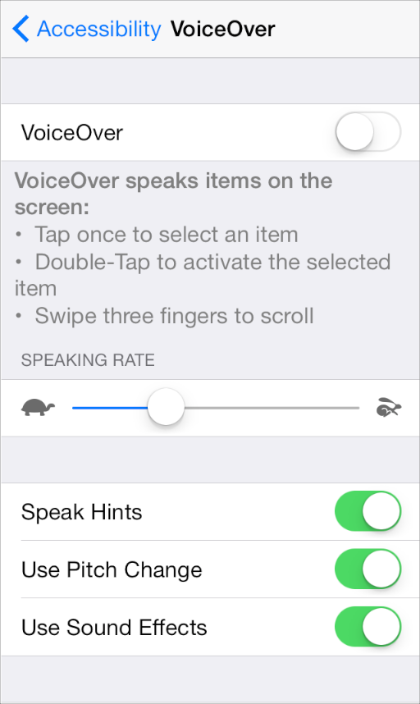

To make sure VoiceOver users can use your app, you might need to supply some descriptive information about the views and controls in your user interface. Supporting VoiceOver does *not*require you to change the visual design of your UI in any way.

When you use standard UI elements in a completely standard way, you have little (if any) additional work to do. The more custom your UI is, the more custom information you need to provide so that VoiceOver can accurately describe your app.

Making your iOS app accessible to VoiceOver users can increase your user base and help you enter new markets. Supporting VoiceOver can also help you address accessibility guidelines created by various governing bodies.

## Routing

Maps can display a choice of routes to a user’s destination:

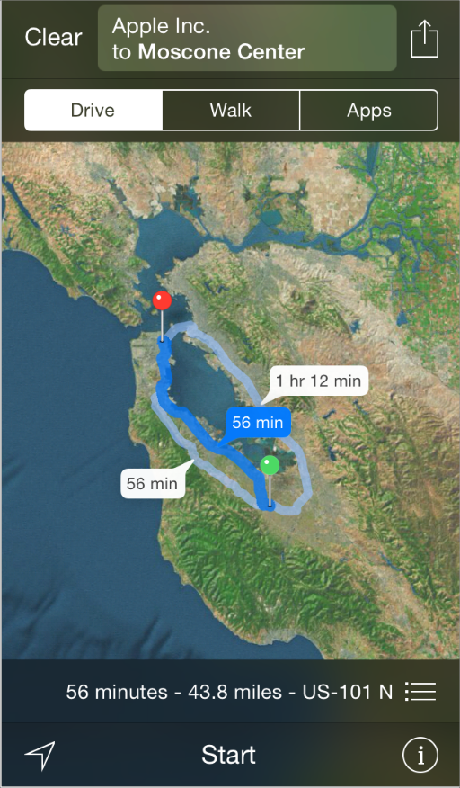

Maps can also display a list of routing apps—including apps installed on the device and in the App Store—when people want additional transit information for a route.

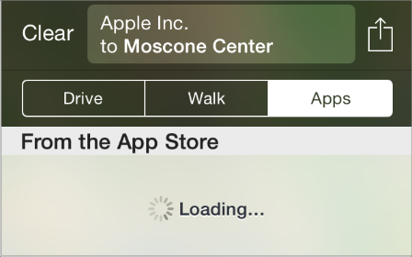

A routing app provides information about transit options for the currently selected route. People expect routing apps to be quick, easy to use, and—above all—accurate. Following the guidelines in this section helps you give users transit information they can trust and a user experience they appreciate.

IMPORTANT

Maps gives people driving and walking directions for their route. Routing apps provide transit information, which focuses on step-by-step directions that use alternate modes of transportation—such as bus, train, subway, ferry, bike, pedestrian, shuttle, and so on.

If your app doesn’t provide transit information for the routes that people specify, don’t identify it as a routing app.

**Deliver the functionality your app promises.** When people see your app in the transit list, they assume that it can help them reach their destination. But if your app can’t provide information about the selected route—or it doesn’t include the type of transit it appears to include—people are unlikely to give it a second chance. It’s essential to represent your app’s capabilities accurately; otherwise, your app can look like it’s intentionally misleading users.

There are two main ways you can give users confidence in your routing app:

* Define the geographic regions you support as precisely as possible. For example, if your app helps people get information about bus routes in Paris, your supported region should be Paris, not Île-de-France, and not France.
* Be specific about the types of transit that you support. For example, if you specialize in subway information, don’t imply that you provide information about all rail-based transit types.

NOTE

Although accurately reporting your supported region can mean that your app appears in the transit list less often, doing so helps users trust it more.

**Streamline the UI for ease of use.** Ease of use is especially important for routing apps because people tend to use them under challenging conditions—such as in bright sunlight or in the dim interior of a train, on a bumpy ride, and when they’re in a hurry. Make sure that your text is easy to read in any light and that buttons are easy to tap accurately even when the ride is not smooth.

**Focus on the route.** Although auxiliary information can be useful, your app should focus on giving users step-by-step directions they can follow to their destination. In particular, you want users to know which step they’re in and how to get to the next step. You can provide additional data—such as timetables and system maps—but don’t make this data more prominent than the transit information.

**Provide information for every step of a route.** People should never feel abandoned by your app. But even when you accurately report your supported region, you can’t assume that users are already at the first transit stop in a route, or that the last transit stop is at the same location as their destination. To handle this situation, first examine the distances at the beginning and end of the route. If the distances are short enough, provide walking directions from the user’s current location to the first transit stop and from the last transit stop to the user’s final destination. If walking is not a reasonable choice, try to describe the user’s other options. If necessary, you can give users a way to open Maps to get walking or driving directions for these portions of the route.

**When users transition to your app from Maps, don’t ask them to reenter information.** If users are coming from Maps, you already know the start and end points of the route they’re interested in, so you can present the appropriate transit information as soon as your app opens. If users start your app from the Home screen, provide an easy way for them to enter route details.

**Display transit information both graphically and textually.** A map view helps people see their complete route in a larger, physical context; a list of steps helps people focus on the actions they must take to arrive at their destination. It’s best when you support both of these tasks and make it easy for users to switch between them.

NOTE

Regardless of format, it’s crucial that you always display the same transit information for the user’s route. For example, if a route consists of five steps, both the map and the list view of the route must describe the same five steps.

When your app is chosen from the transit list, it works well to start by displaying the complete route—including walking paths to and from the transit stops, if appropriate—in a map view. A map view gives users an overview of the various steps in their journey and shows them how their route fits into the surrounding geographical area.

**Enrich map views with additional information.** People expect the maps in your app to behave similarly to other maps they’ve used. In addition to letting users zoom and pan, you should display annotations that give users the information they need. For example, you could display pins that represent the user’s current location, the destination, and transfers or points of interest along the way. Be sure to avoid displaying only a single pin, because it’s hard for users to tell what it represents if there’s no additional context. For more information about using map views in your app, see [Map View](https://developer.apple.com/library/ios/documentation/UserExperience/Conceptual/MobileHIG/ContentViews.html#//apple_ref/doc/uid/TP40006556-CH13-SW134).

As much as possible, integrate static maps—such as a subway system map—with a map view. A good way to do this is to overlay the static image on the map view so that users can see how their route and their current location relate to the larger transit system.

NOTE

If you decide to display a static map image by itself, be sure to use a high-resolution image that maintains good quality when users zoom into it.

**Give users different ways to sort multiple transit options.** Lots of factors influence people’s transit decisions—such as time of day, weather, and how much they’re carrying—so it’s important to make it easy to compare transit options. For example, you could let users sort transit options by start or end time, amount of walking required, number of stops along the way, or number of transfers or different transit types required. Regardless of the order in which you display multiple transit options, make sure that users can instantly distinguish the differences between the options.

**Consider using push notifications to give people important information about their route.**As much as possible, let people know when transit information changes, so that they can adjust their plans. For example, if a train is delayed or a bus line is temporarily unavailable people might need to choose a different route to their destination. And in a route that includes long stops between steps, people might appreciate being notified when their transport is about to depart for the next part of the journey.

## Edit Menu

Users can reveal an edit menu to perform operations such as Cut, Paste, and Select in a text view, web view, or image view.

The edit menu

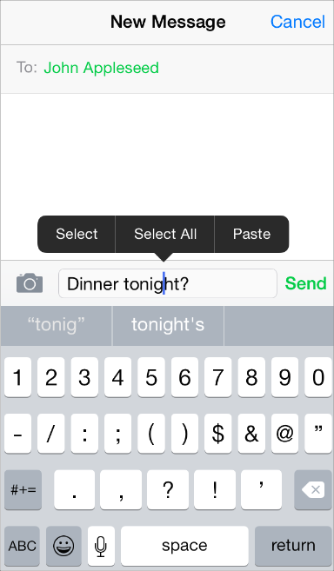

The selection menu

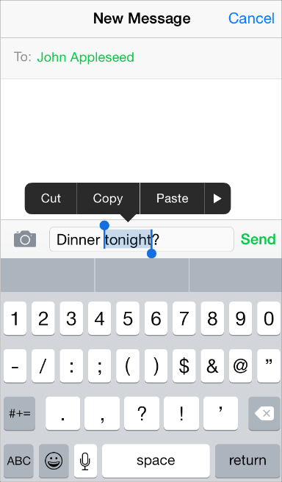

You can adjust some of the behaviors of the menu to give users more control over the content in your app. For example, you can:

* Specify which of the standard menu commands are appropriate for the current context
* Determine the position of the menu before it appears so that you can prevent important parts of your app’s UI from being obscured
* Define the object that is selected by default when users double-tap to reveal the menu

You can't change the color or shape of the menu itself.

For information on how to implement these behaviors in code, see [Copy, Cut, and Paste Operations](https://developer.apple.com/library/ios/documentation/StringsTextFonts/Conceptual/TextAndWebiPhoneOS/UsingCopy,Cut,andPasteOperations/UsingCopy,Cut,andPasteOperations.html#//apple_ref/doc/uid/TP40009542-CH11).

To ensure that the edit menu behaves as users expect in your app, you should:

**Display commands that make sense in the current context.** For example, if nothing is selected, the menu should not contain Copy or Cut because these commands act on a selection. Similarly, if something is selected, the menu should not contain Select. If you support an edit menu in a custom view, you’re responsible for making sure that the commands the menu displays are appropriate for the current context.

**Accommodate the menu display in your layout.** iOS displays the edit menu above or below the insertion point or selection, depending on available space, and places the menu pointer so that users can see how the menu commands relate to the content. You can programmatically determine the position of the menu before it appears so that you can prevent important parts of your UI from being obscured, if necessary.

**Support both gestures that people can use to invoke the menu.** Although the touch and hold gesture is the primary way users reveal the edit menu, they can also double-tap a word in a text view to select the word and reveal the menu at the same time. If you support the menu in a custom view, be sure to respond to both gestures. In addition, you can define the object that is selected by default when the user double taps.

**Avoid creating a button in your UI that performs a command that’s available in the edit menu.** For example, it’s better to allow users to perform a copy operation using the edit menu than to provide a Copy button, because users will wonder why there are two ways to do the same thing in your app.

**Consider enabling the selection of static text if it’s useful to the user.** For example, a user might want to copy the caption of an image, but they’re not likely to want to copy the label of a tab item or a screen title, such as Accounts. In a text view, selection by word should be the default.

**Don’t make button titles selectable.** A selectable button title makes it difficult for users to reveal the edit menu without activating the button. In general, elements that behave as buttons don’t need to be selectable.

**Combine support for undo and redo with your support of copy and paste.** People often expect to be able to undo recent operations if they change their minds. Because the edit menu doesn’t require confirmation before its actions are performed, you should give users the opportunity to undo or redo these actions.

Follow these guidelines if you need to create custom edit menu items, such as the ones shown here:



**Create edit menu items that edit, alter, or otherwise act directly upon the user’s selection.**People expect the standard edit menu items to act upon text or objects within the current context, and it’s best when your custom menu items behave similarly.

**List custom items together after all system-provided items.** Don’t intersperse your custom items with the system-provided ones.

**Keep the number of custom menu items reasonable.** You don’t want to overwhelm your users with too many choices.

**Use succinct names for your custom menu items** and make sure the names precisely describe what the commands do. In general, item names should be verbs that describe the action to be performed. Although you should generally use a single capitalized word for an item name, use title-style capitalization if you must use a short phrase. (Briefly, title-style capitalization means to capitalize every word except articles, coordinating conjunctions, and prepositions of four or fewer letters.)

## Undo and Redo

Users initiate an Undo operation by shaking the device, which displays an alert that allows them to:

* Undo what they just typed
* Redo previously undone typing
* Cancel the undo operation

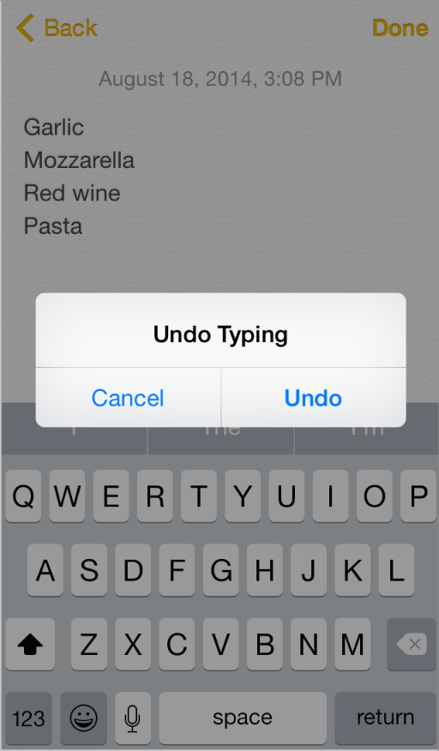

You can support the Undo operation in a more general way in your app by specifying:

* The actions users can undo or redo
* The circumstances under which your app should interpret a shake event as the shake-to-undo gesture
* How many levels of undo to support

To learn how to implement this behavior in code, see [*Undo Architecture*](https://developer.apple.com/library/ios/documentation/Cocoa/Conceptual/UndoArchitecture/UndoArchitecture.html#//apple_ref/doc/uid/10000010i). If you support undo and redo in your app, follow these guidelines to provide a good user experience.

**Supply brief descriptive phrases that tell users precisely what they’re undoing or redoing.**iOS automatically supplies the strings “Undo “ and “Redo “ (including a space after the word) for the undo alert button titles, but you need to provide a word or two that describes the action users can undo or redo. For example, you might supply the text Name or Address Change, to create button titles such as “Undo Name” or “Redo Address Change.” (Note that the Cancel button in the alert cannot be changed or removed.)

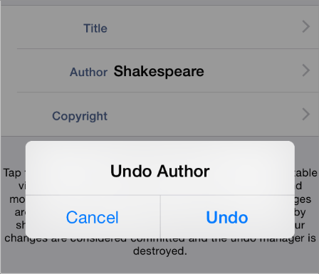

**Avoid supplying text that is too long.** A button title that is too long is truncated and is difficult for users to decipher. And because this text is in a button title, use title-style capitalization and do not add punctuation.

**Avoid overloading the shake gesture.** Even though you can programmatically set when your app interprets a shake event as shake to undo, you run the risk of confusing users if they also use shake to perform a different action. Analyze user interaction in your app and avoid creating situations in which users can’t reliably predict the result of the shake gesture.

**Use the system-provided Undo and Redo buttons only if undo and redo are fundamental tasks in your app.** Remember that the shake gesture is the primary way users initiate undo and redo, and that it can be confusing to offer two different ways to perform the same task. If you decide it’s important to provide explicit, dedicated controls for undo and redo, you can place the system-provided buttons in the navigation bar. (To learn more about these buttons, see [Toolbar and Navigation Bar Buttons](https://developer.apple.com/library/ios/documentation/UserExperience/Conceptual/MobileHIG/Bars.html#//apple_ref/doc/uid/TP40006556-CH12-SW33).)

**Clearly relate undo and redo capability to the user’s immediate context, and not to an earlier context.** Consider the context of the actions you allow to be undone or redone. In general, users expect their changes and actions to take effect immediately.

## Keyboards and Input Views

In iOS 8 and later, you can create a custom keyboard extension that people can use instead of the system-provided keyboard in most places. To learn more about the guidelines that govern app extensions including keyboards, see [App Extensions](https://developer.apple.com/library/ios/documentation/UserExperience/Conceptual/MobileHIG/AppExtensions.html#//apple_ref/doc/uid/TP40006556-CH67-SW1); to learn how to develop a custom keyboard extension, see [Custom Keyboard](https://developer.apple.com/library/ios/documentation/General/Conceptual/ExtensibilityPG/Keyboard.html#//apple_ref/doc/uid/TP40014214-CH16).

If appropriate, you can also design a custom input view to replace the system-provided onscreen keyboard within your app. For example, Numbers provides several input views that are designed to make it easy and efficient to enter amounts, dates, and other values.

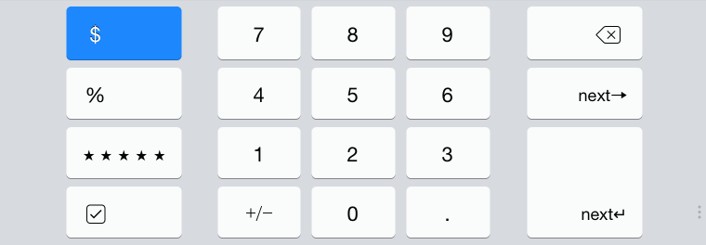

If you provide a custom input view, be sure its function is obvious to people.

You can also provide a custom input accessory view, which is a separate view that appears above the keyboard (or your custom input view). For example, in some contexts, Numbers displays an input accessory view that helps users perform standard or custom calculations on spreadsheet values.

mage: ../Art/input_accessory2_2x.png

Use the standard keyboard click sound to provide audible feedback when people tap the custom controls in your input view. To learn how to enable this sound in your code, see the documentation for [playInputClick](https://developer.apple.com/library/ios/documentation/UIKit/Reference/UIDevice_Class/index.html#//apple_ref/occ/instm/UIDevice/playInputClick) in [*UIDevice Class Reference*](https://developer.apple.com/library/ios/documentation/UIKit/Reference/UIDevice_Class/index.html#//apple_ref/doc/uid/TP40006902).

NOTE

The standard click sound is available only for custom input views that are currently onscreen. People can turn off all keyboard clicks—including ones that come from your custom input view—in Settings > Sounds.